**PROJECT REPORT**

**CBC-EDU TRIAD**

The Framework for Competency-Based Project Assessment and showcase.

BY

**WAMILIMO HILLARY**

**BSCLMR288922**

# ABSTRACT

This project developed CBC-EDU-TRIAD system, a web-based framework to streamline Competency-Based Education (CBE) assessment for students. It enhances a good flow between teachers, students, parents and administration in one place. The system integrated modules for project submission, competency-task mapping, rubric-based assessment and feedback, and parental progress monitoring, student showcase, admin management tool. Using an Agile methodology (10 sprints), the platform was built with Python leveraging (Flask), PostgreSQL, and vanilla JavaScript & Jinja2, featuring Role-Based Access Control (RBAC) for secure interactions, dynamic competency tracking, automated submission status (Pending/Submitted/Overdue), and token-based authentication, cryptographic (SHA-256) with email verifications. Rigorous testing confirmed 100% success in RBAC enforcement, competency-task alignment, and parental feedback integration. The modular MVC architecture and parameterized queries enhanced scalability and security. CBC-EDU-TRIAD effectively addressed gaps in CBC project assessment, offering a user-centric, scalable solution. Future work could explore AI-assisted grading and mobile app development for offline access. Keywords: Competency-Based Education, Role-Based Access Control, Rubric Assessment**.**

TABLE OF CONTENT

ABSTRACT i

LIST OF ABBREVIATIONS iv

LIST OF TABLES v

LIST OF FIGURES vi

CHAPTER 6 - IMPLEMENTATION AND TESTING 1

Introduction 1

6.1 Development Environment 1

Project Structure 2

Development Methodology 3

6.2 System Components 4

6.2.1 System Users 4

6.2.2 Authentication and Registration 7

6.2.3 Password Recovery System 9

6.2.4 Task Competency Mapping Module 10

6.2.5 Project Submission Module 11

6.2.6 Assessment and Feedback Module 14

6.2.7 Admin Management Tools Module 15

6.2.7 Parental Involvement Module 17

6.3 Test Plan 18

6.3.1 Test Data 18

6.3.2 Test Cases and Results 21

6.4 Database Implementation 33

38

CHAPTER 7 - SUMMARY, CONCLUSIONS, AND RECOMMENDATIONS 41

7.1 Achievements and Lessons Learnt 41

7.1.1 Achievements 41

7.1.2 Technical Lessons Learnt 41

7.2 Conclusions 43

7.3 Recommendations 44

APPEDICES 45

REFERENCES 46

# LIST OF ABBREVIATIONS

**API** - Application Programming Interface

**DB** - Database

**HTML** - HyperText Markup Language

**JS** - JavaScript

**RBAC** - Role-Based Access Control

**SQL** - Structured Query Language

**UI** - User Interface

**UX** - User Experience

# LIST OF TABLES

Table 1:Development Environment Components 1

Table 2:Agile Sprint Summary 3

Table 3:Teachers 18

Table 4:Parents 18

Table 5:Students 18

Table 6:Competencies 19

Table 7:Criteria 19

Table 8:Classes 19

Table 9:Class and Students 20

Table 10:Student Groups 20

Table 11:Performance Levels 20

# LIST OF FIGURES

Figure 1:FIGURE CBC-EDU-TRIAD Project Structure 2

Figure 2:Landing page 4

Figure 3:Responsive landing page 4

Figure 4:admin dashboard 5

Figure 5:teachers panel 5

Figure 6:parents panel 6

Figure 7:student panel 6

Figure 8:Teacher Login form 7

Figure 9:Student authentication form 7

Figure 10:Parent login form 8

Figure 11:Parent registration form 8

Figure 12:Administration login 8

Figure 13:Request reset form 9

Figure 14:Request reset form 9

Figure 15:Submitting for group 12

Figure 16:individual submission 12

Figure 17:Student projects submitted 13

Figure 18:Admin dashboard 15

Figure 19:Admin user Management(Teachers) 16

Figure 20:Add teacher form 16

Figure 21:Performance level management 16

Figure 22:Performance level modal form 17

Figure 23:parent with no linked student 21

Figure 24:Linked parent and student 21

Figure 25:Role-Based Access Control error 22

Figure 26:Mapping a competency to task 22

Figure 27:The task and submission status 23

Figure 28:mapped competency critical thinking and problem solving 23

Figure 29:Only Relevant criteria for competency 24

Figure 30:Student1 view their assigned 25

Figure 31:Student1 view their assigned 25

Figure 32:Teacher 1 get submissions 26

Figure 33:Teacher 2 get submissions 26

Figure 34:Student 1 results and feedbacks 27

Figure 35:Feedback criteria breakdown 27

Figure 36:verify email to login 28

Figure 37:mailtrap inbox email testing 28

Figure 38:Password securely changed 29

Figure 39:verified emails 29

Figure 40:Edit and activate user account 30

Figure 41:Add criteria 30

Figure 42:add criteria 31

Figure 43:Before added to class 32

Figure 44:After added to a class 32

# CHAPTER 6 - IMPLEMENTATION AND TESTING

## Introduction

This chapter outlines the development environment, system components, and the testing procedures used to implement the CBC-EDU Triad system.

## 6.1 Development Environment

The system was developed using the following technologies:

|  |  |  |
| --- | --- | --- |
| **Component** | **Technology / Tool** | **Purpose** |
| **Frontend** | HTML, CSS, Vanilla JavaScript, Jinja2 templating | For structuring the UI, styling, and adding interactivity. |
| **Backend** | Python 3.10 | For backend logic and database interactivity. |
| **Backend Framework** | Flask 2.3.2 | For building the web server, handling requests, and routing. |
| **ORM** | SQL Alchemy ORM | For interacting with the PostgreSQL database using Python objects. |
| **Database Adapter** | Psycopg2 | For establishing the connection between Python and PostgreSQL for executing SQL queries. |
| **Database** | PostgreSQL (v15) | For storing and managing the system's data. |
| **Version Control** | Git & GitHub | For code tracking and backup on GitHub codebase. |
| **Password Hashing** | SHA-256 | For securely hashing and storing passwords. |
| **Emails testing** | Mailtrap server | For email testing such as verification, notifications and password recoveries |

Table :Development Environment Components

### Project Structure

**Overview**  
The CBC-EDU Triad project was structured for modularity to enhance scalability, maintainability, and overall performance. The development adopted an MVC-like pattern, which separated models, queries, routes, and templates. This organizational structure followed modularization principles breaking the system into smaller, reusable components to improve readability, scalability, and ease of maintenance (Real Python, n.d.).  
**The modular structure offered several benefits**

1. **Reusability** – Shared components like the database connection utility were reused across multiple routes without duplication.
2. **Separation of Concerns** – Routes, database logic, and templates were clearly separated into dedicated modules.
3. **Scalability** – New functionalities were added without affecting existing features, making the system easy to scale.
4. **Readability** – The code was easier to follow due to logical organization.
5. **Maintainability** – Fixes or updates were made more efficiently thanks to clean separation and modular logic.

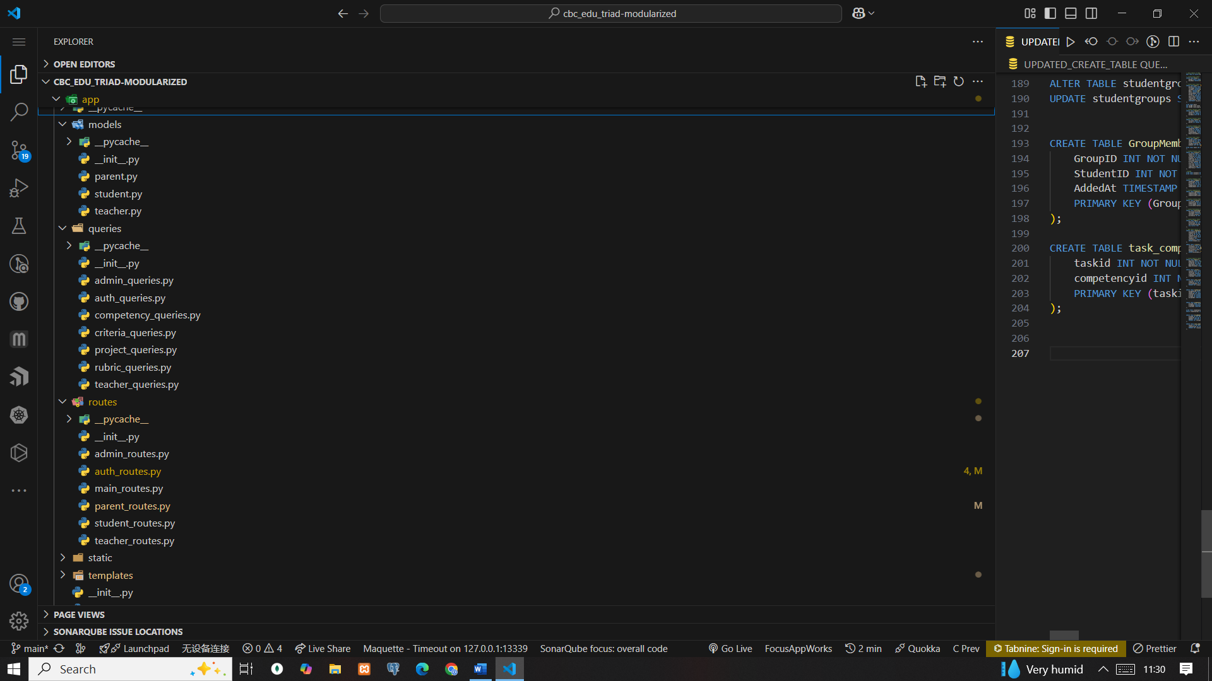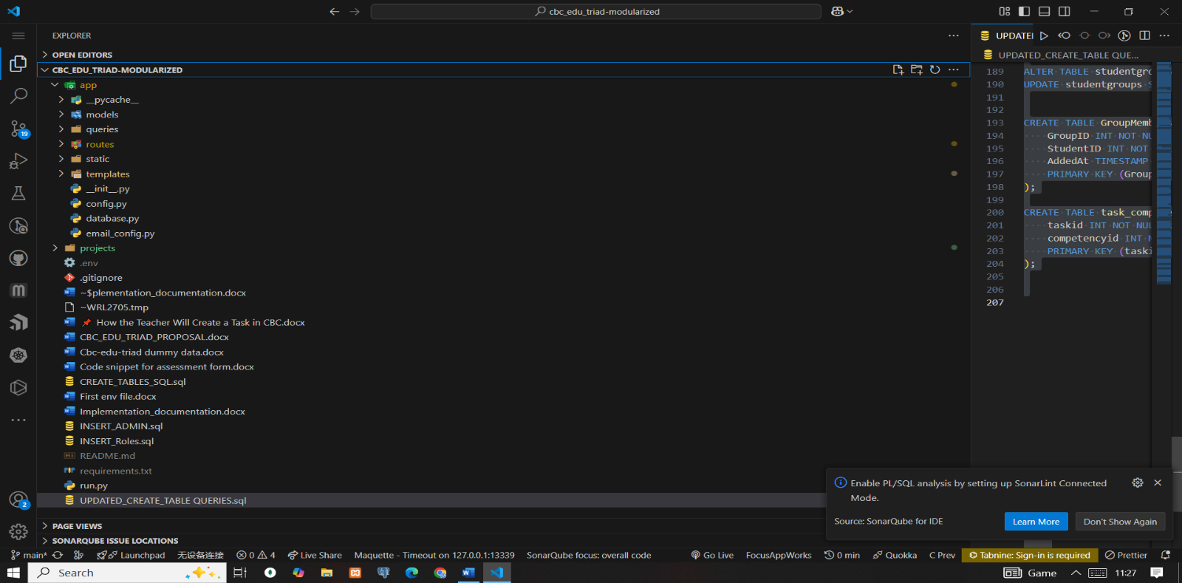

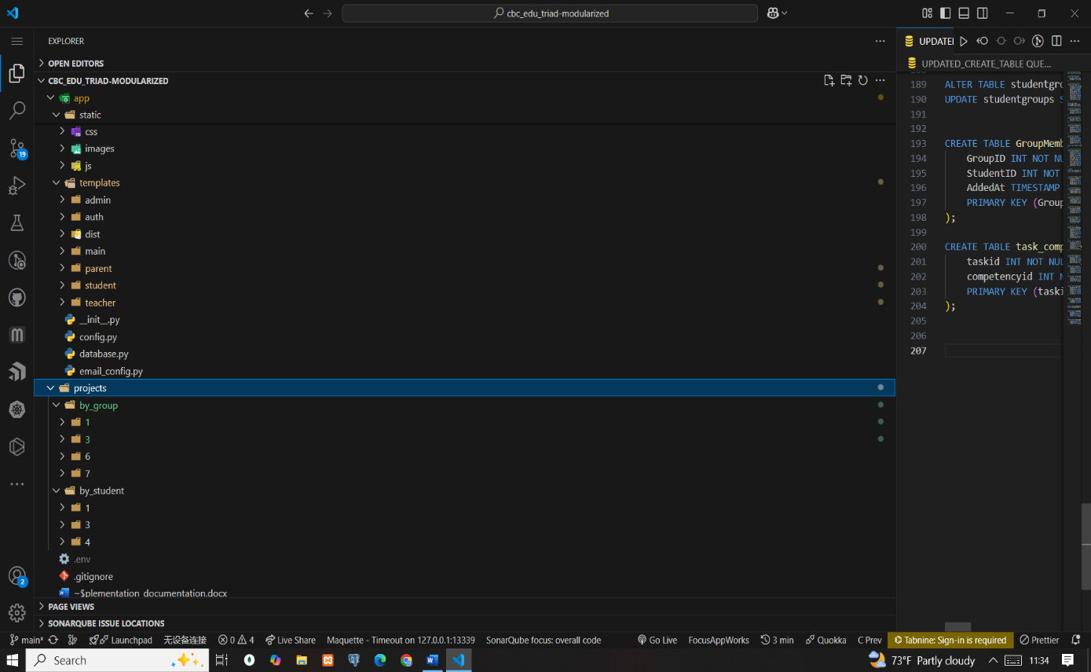

Figure :FIGURE CBC-EDU-TRIAD Project Structure

### Development Methodology

The project adopted an Agile development approach, executed through iterative sprints. Agile was selected for its flexibility, responsiveness to user feedback, and suitability for building education-based systems like CBC-EDU Triad. (asana n.d.). Development followed a logical flow from independent to dependent components. For instance, authentication logic was created before finalizing related database tables, while task assignment was completed prior to assessment module development.

Each sprint focused on specific functionality and was followed by testing. If new ideas arose, previous sprints were revisited to refine.

|  |  |
| --- | --- |
| **Sprint** | **Description** |
| **Sprint 1** | Focused on UI implementation, including the landing page, core pages, and all user dashboards. |
| **Sprint 2** | Involved designing the database and executing structured SQL statements to create required tables. |
| **Sprint 3** | Handled user registration and authentication mechanisms. |
| **Sprint 4** | Developed admin dashboard functionalities: class creation, user management, competency setup, criteria definition, and student-class assignment. |
| **Sprint 5** | Covered teacher task assignment, student task viewing, group creation, and task management. |
| **Sprint 6** | Introduced the project submission module, allowing students to upload tasks. |
| **Sprint 7** | Included teacher access to submissions, assessment workflows, feedback system integration, and rubric-based evaluation. |
| **Sprint 8** | Presented student competency overviews, criteria breakdowns, and result tracking. |
| **Sprint 9** | Enabled parents to view their linked student’s competency progress and feedback. |
| **Sprint 10** | Finalized user profile management for all roles. |

Table :Agile Sprint Summary

Throughout the entire cycle, each sprint was tested before progressing and documentation done at each phase.

## 6.2 System Components

The CBC-EDU Triad system comprised of the following major components:

### 6.2.1 System Users

The system supports **Parents**, **Students**, **Teachers**, and **Admin** roles with specific functionalities and access levels.

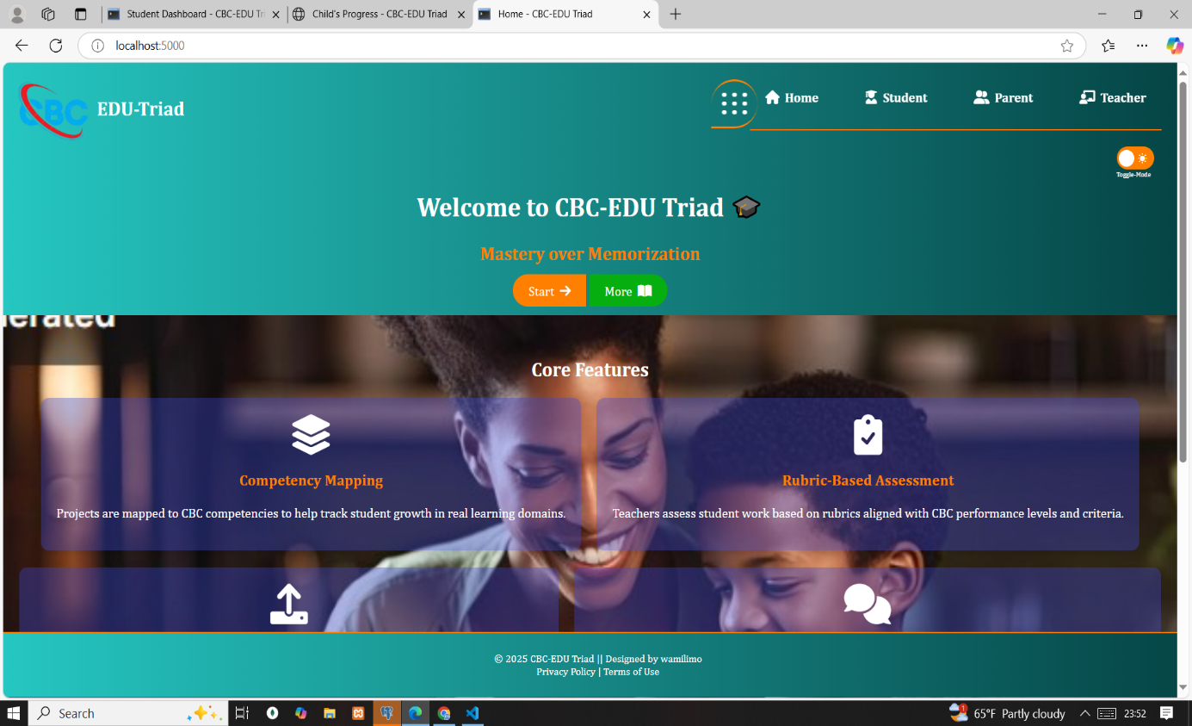

Figure :Landing page

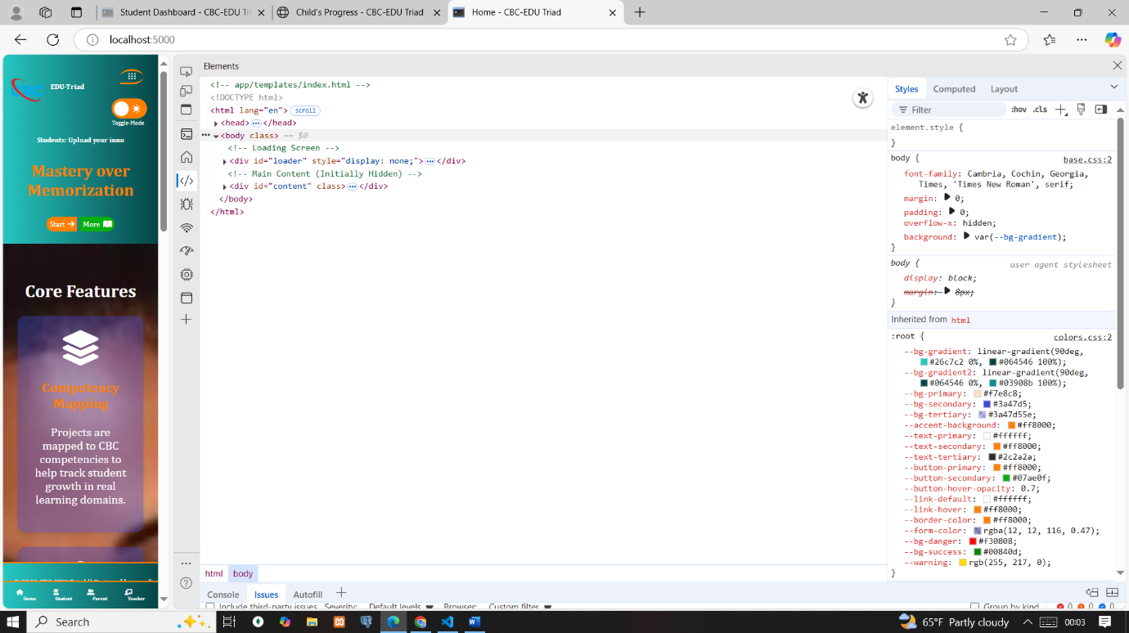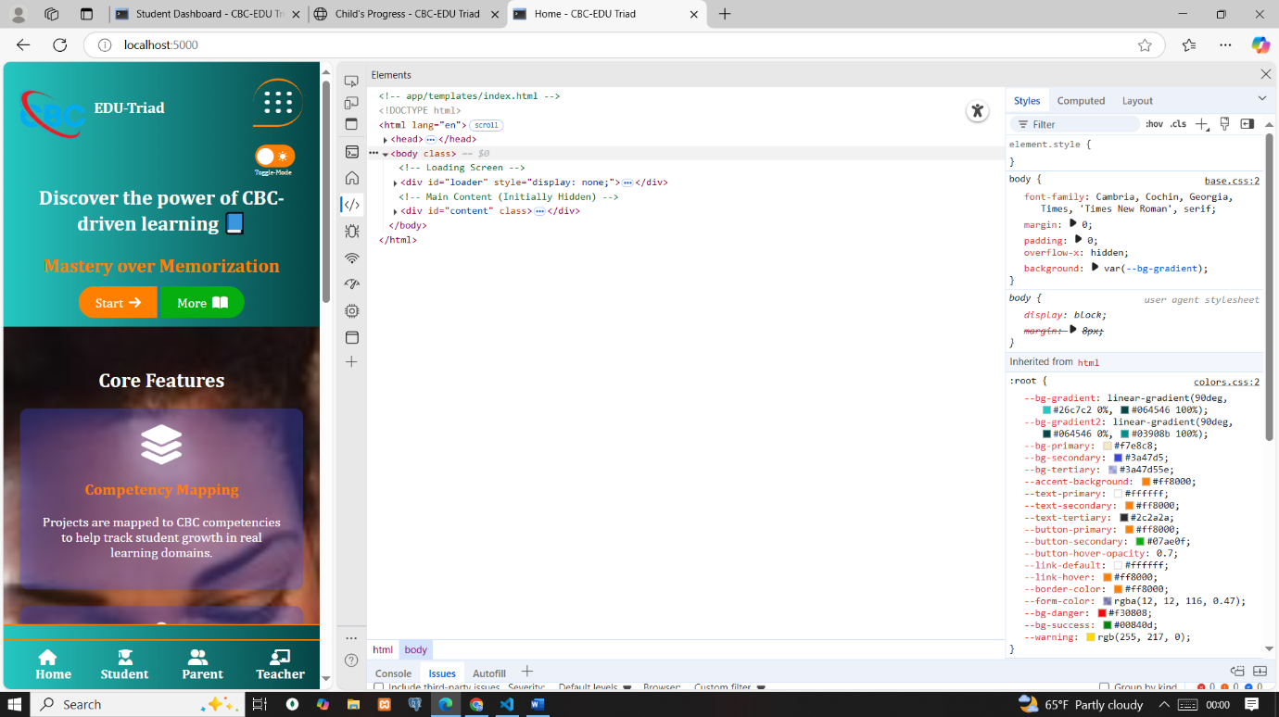

Figure :Responsive landing page

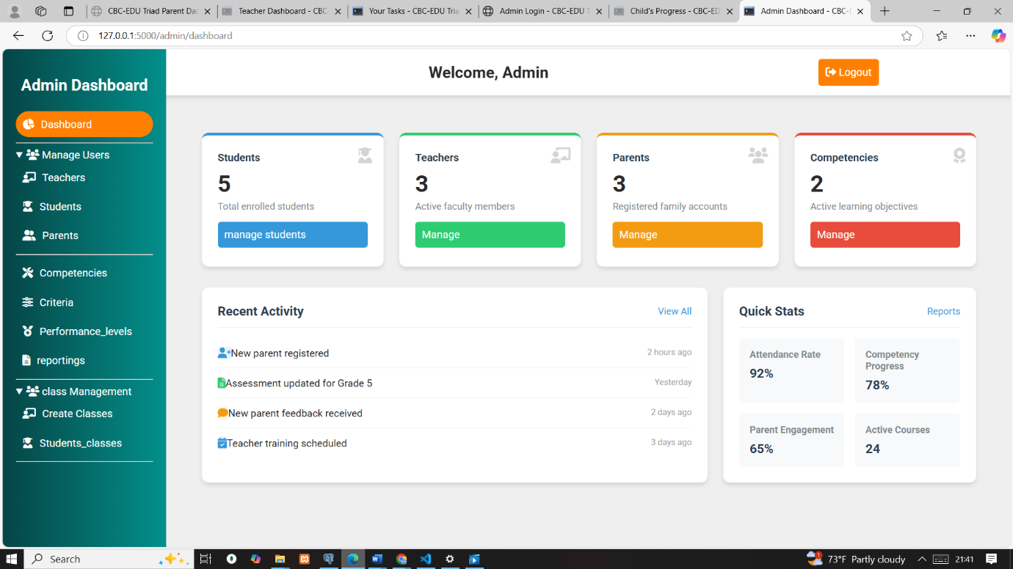

Figure :admin dashboard

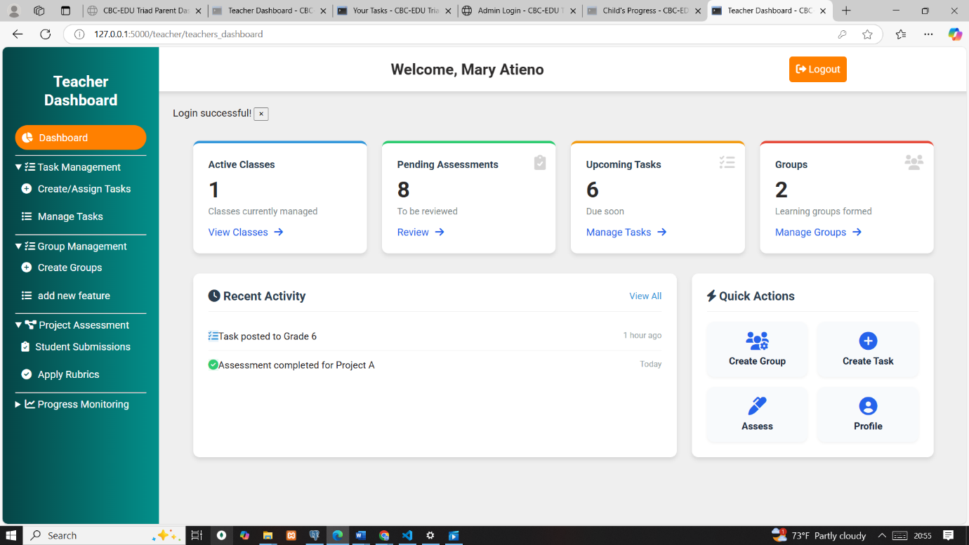

Figure :teachers panel

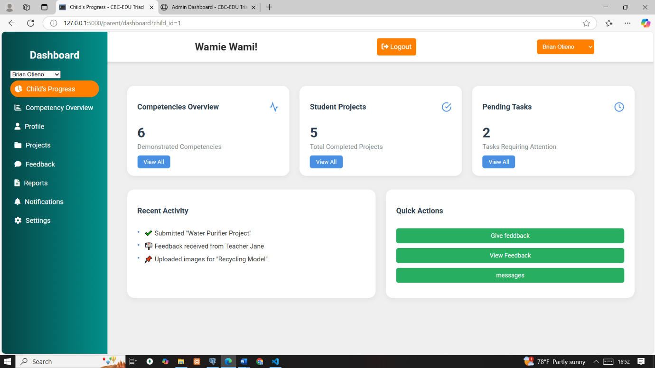

Figure :parents panel

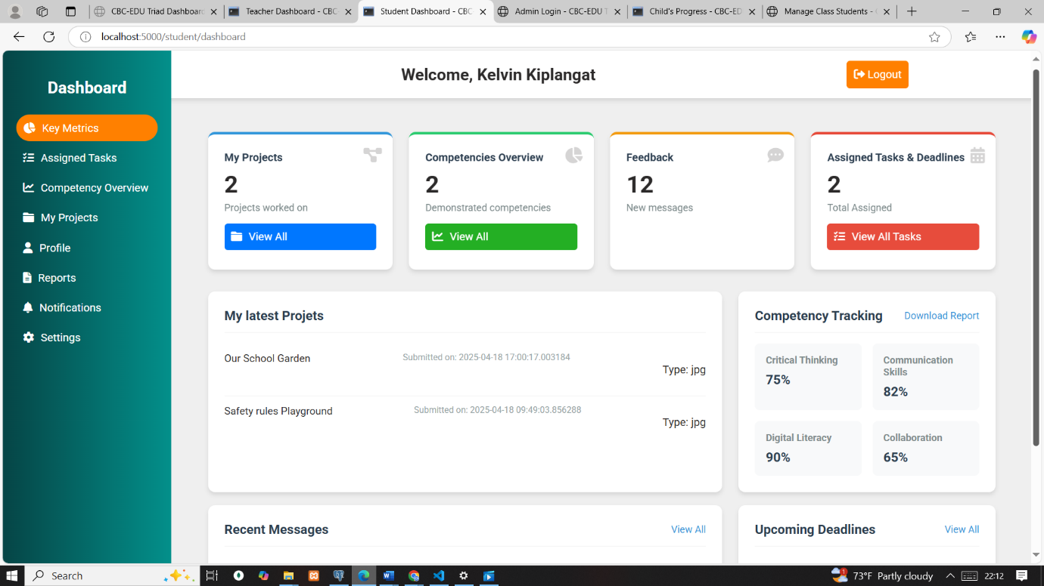

Figure :student panel

### 6.2.2 Authentication and Registration

The system implemented Role-Based Access Control (RBAC) to manage secure access for students, teachers, parents, and administrators. Teachers and students were registered internally by the admin, while parents registered themselves through a structured online form that included an email verification step. Upon successful verification, accounts were activated, and parents could log in using either their email or phone number alongside a password. The admin handled the linking of parents to one or more students. During login, the system validated credentials by comparing the entered password with a securely stored hash generated using SHA-256. Verified users were redirected to their role-specific dashboards. User sessions were maintained using Flask’s session management. Route protection was enforced using decorators such as @login_required, along with custom role checks to restrict access based on the user type. Security was enhanced by verifying emails during registration and storing only hashed passwords to protect user data.

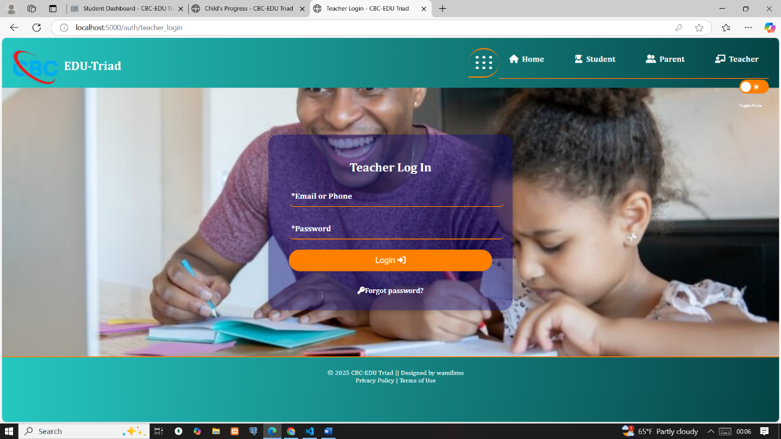

Figure :Teacher Login form

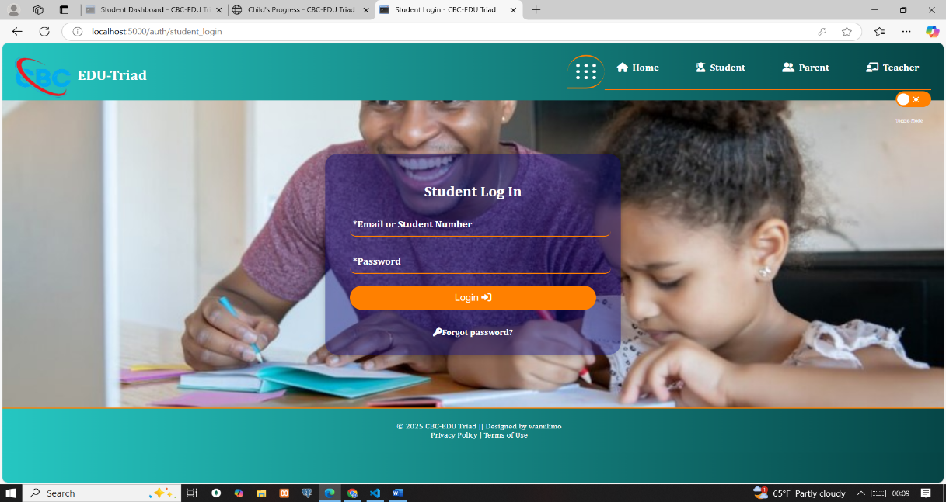

Figure :Student authentication form

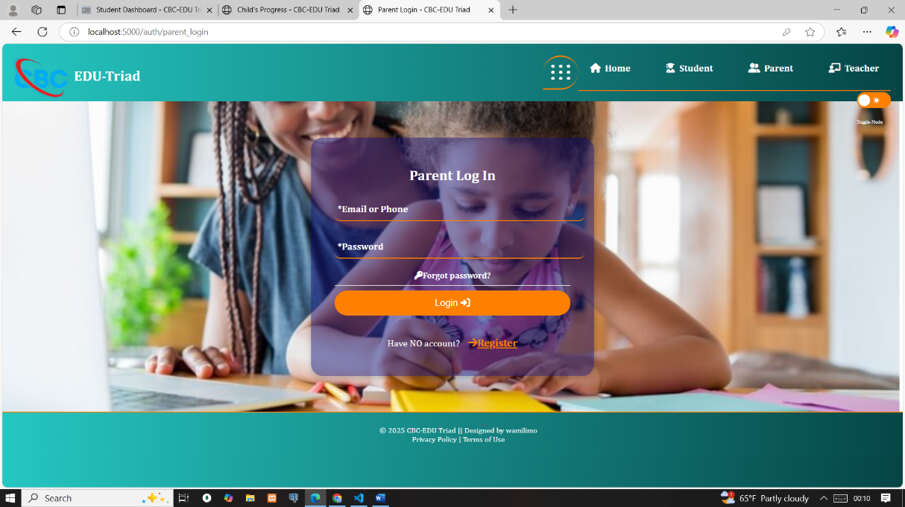

Figure :Parent login form

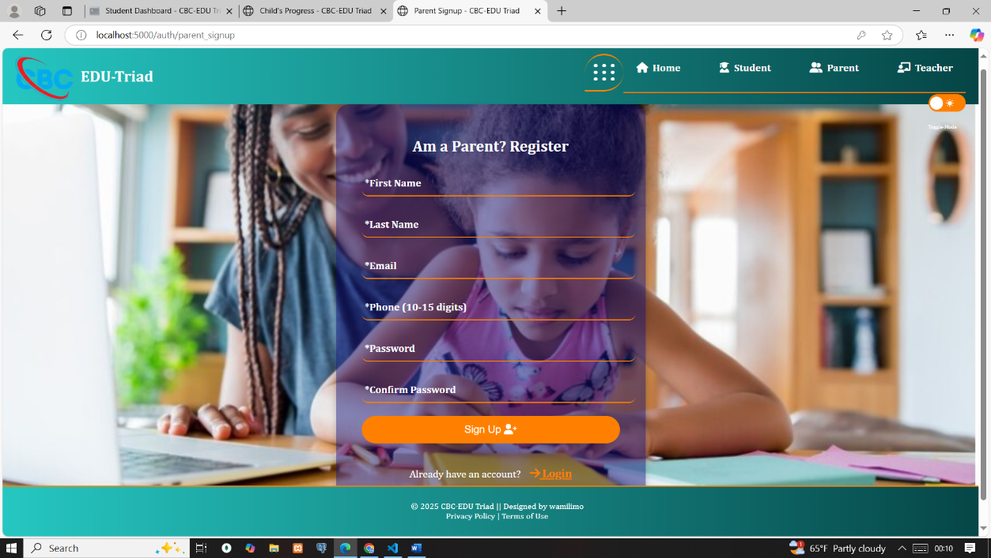

Figure :Parent registration form

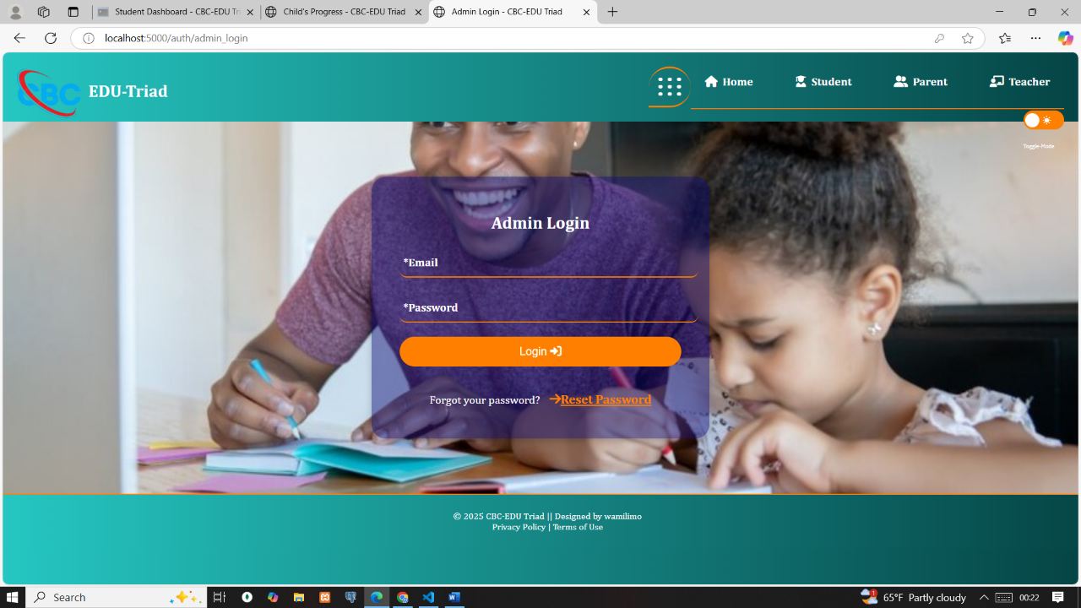

Figure :Administration login

### 6.2.3 Password Recovery System

The password recovery system enabled users to reset forgotten passwords through a secure, token-based process. When a user requested a reset, the system generated a unique, time-bound token using cryptographic hashing and stored it along with a timestamp in the database. A reset link containing the token was sent to the user’s registered email address. Once the link was accessed, the system validated the token and ensured it had not expired—tokens remained valid for one hour or until first use. Users were required to enter a new password that met complexity requirements, including a minimum of eight characters and at least one special character, along with a confirmation field to reduce entry errors. After the password was successfully reset, the token was invalidated, and the user was redirected to the login page.

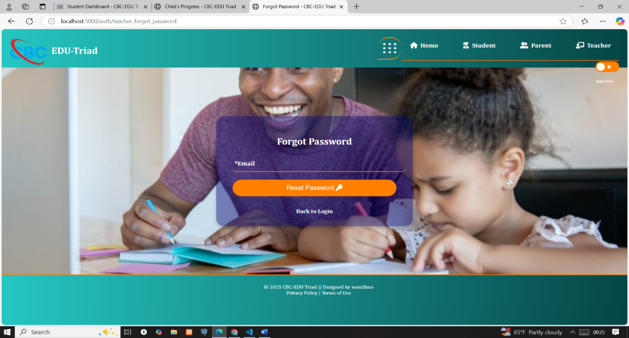

Figure :Request reset form

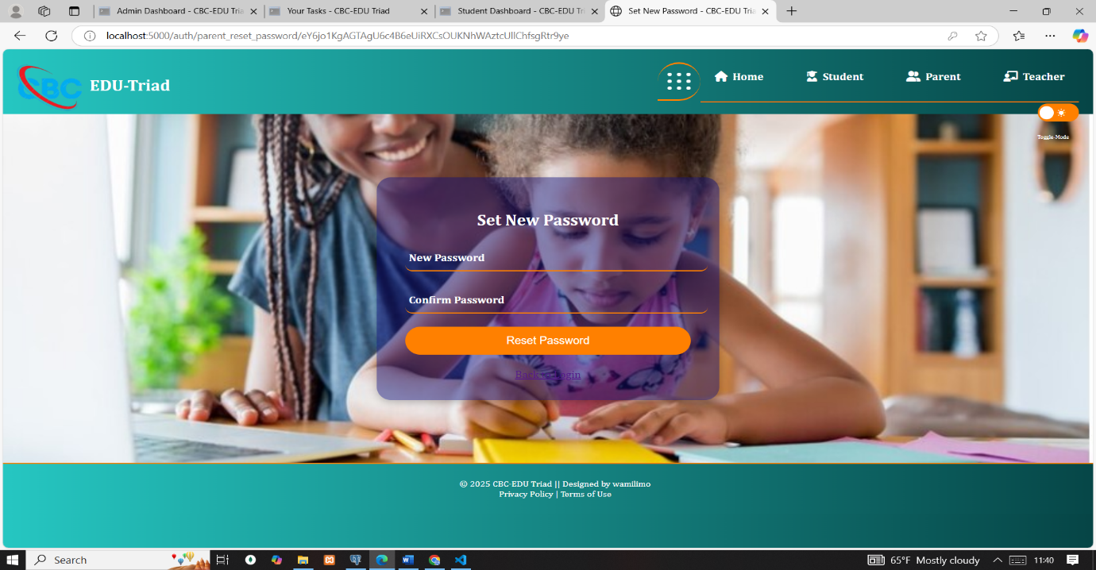

Figure :Request reset form

### 6.2.4 Task Competency Mapping Module

This module enabled teachers to create tasks and map them directly to specific competencies, supporting a competency-based assessment approach. During task creation, teachers entered a title, set a due date, and provided a description. A core feature involved mapping the task to a selected competency (e.g., *Critical Thinking*, *Collaboration*), which guided future assessment.

The teacher then selected the intended recipients of the task. Assignment options included:

1. A specific student (from their class),
2. A group (created by the same teacher), or
3. An entire class (assigned to the teacher by the admin).

The form was dynamic student, group, and class options were automatically filtered to show only those under the teacher’s scope. This filtering was enforced through object-oriented programming (OOP) principles, ensuring data encapsulation and proper access control. A teacher could not assign tasks to students or groups outside their assigned classes.

The task visibility on the student side depended on the assignment type:

1. **Class-level:** all students in the class viewed the task.
2. **Group-level:** only members of the assigned group accessed it.
3. **Individual:** only the selected student could view and submit.

Dropdown menus simplified the interface, allowing teachers to easily select competencies and recipients. Each task’s linked competency became the focal point for assessment and feedback, maintaining the system's competency-driven model.

### 6.2.5 Project Submission Module

The system enabled students to access their assigned tasks, track submission statuses, and upload corresponding project files. Submission status was dynamically determined based on whether the task had been submitted and whether it was on time or overdue. Tasks were marked as Pending, Submitted, or Overdue through a logic that compared actual submission timestamps with the respective task deadlines. If a student submitted a task on time, it was recorded as Submitted; if the deadline had passed, it was labelled Overdue. The platform allowed both individual and group submissions, with a single submission by any group member reflecting across all members linked to that task. To maintain data integrity, each task permitted only one submission per student or group.

Uploaded files were stored within a structured directory under the projects folder. The system captured metadata such as file size and file type during upload, which allowed validation and standardization of submissions. It enforced restrictions such as supported file types and a maximum file size of 20MB. File types included PDF documents for reports, DOCX and XLS files for text and data-based projects, PPT for presentations, and multimedia formats such as MP4, MP3, JPG, PNG, and GIF for visual or audio-based deliverables.

The system flagged late submissions and indicated them clearly in the student interface using a color-coded status: green for Submitted, red for Overdue, and blue for Pending. While late submissions were allowed, they were visibly marked, and teachers could apply grading penalties as needed. This setup ensured clarity in task expectations and submission compliance across all users.

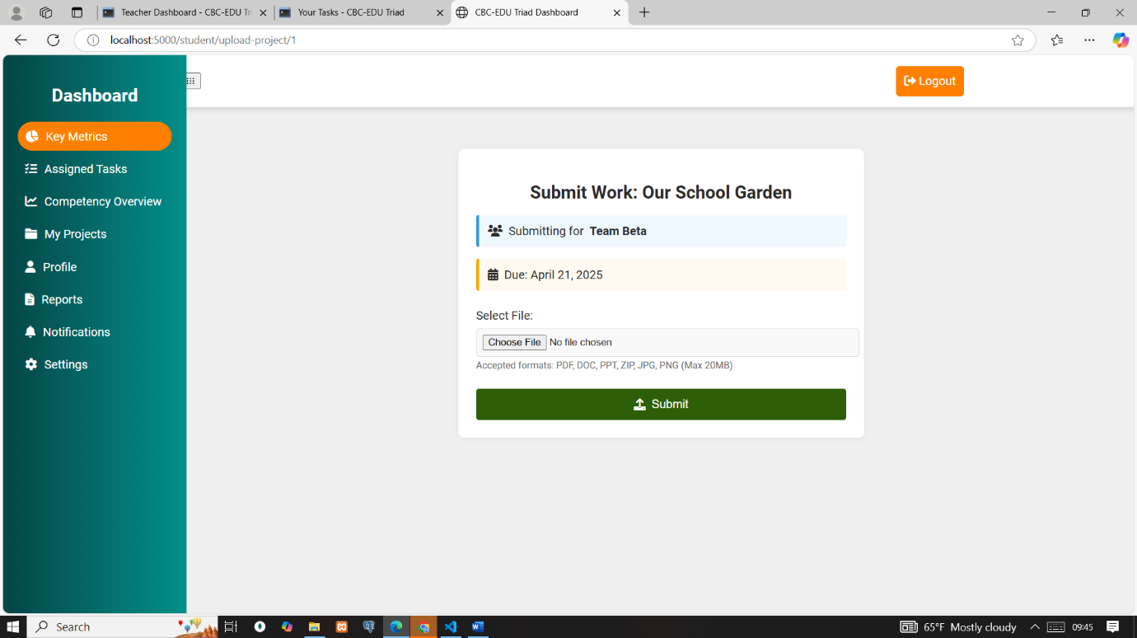

Figure :Submitting for group

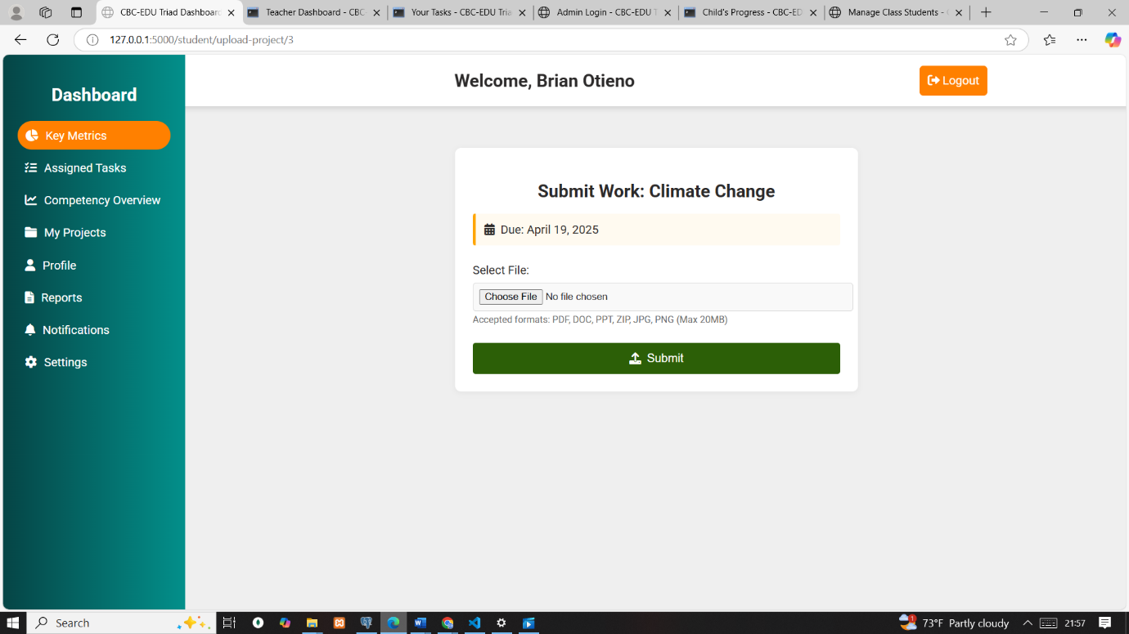

Figure :individual submission

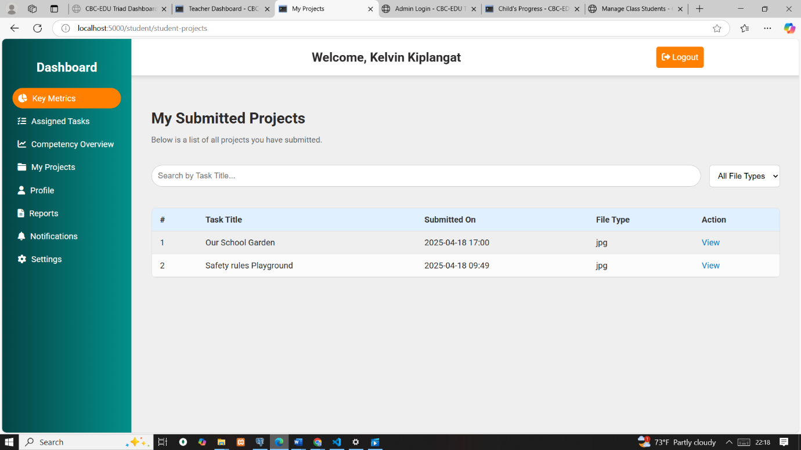

Figure :Student projects submitted

### 6.2.6 Assessment and Feedback Module

This module enabled teachers to assess student and group project submissions and provide structured feedback aligned with CBC competencies. Once a student or group submitted a task, the system displayed submission details such as the task title, due date, submission timestamp, group name and whether it was submitted late.

To begin assessment, a teacher selected a specific submission. The system then loaded the corresponding competency mapped to the task, along with its associated assessment criteria and performance levels. Performance levels were predefined and linked to each criterion under the selected competency.

Teachers assessed each criterion by selecting an appropriate performance level from dropdown menus. They could also add qualitative feedback to support the numerical evaluation. The system automatically computed a score based on the selected performance levels and recorded the overall performance.

Assessments were securely saved and time-stamped. Once a submission was marked, its status changed to "Assessed," preventing further assessment. Group submissions applied the same evaluation to all members, ensuring consistency. For individual tasks, feedback and scores were displayed in the student’s personal dashboard.

A key design feature enforced strict access control through object-oriented programming (OOP) principles. Each teacher only viewed and assessed submissions for tasks they had personally assigned whether to a student, group, or class. They were unable to access submissions that were not created by them. This encapsulation ensured data privacy, integrity, and a clear chain of instructional responsibility.

Dropdown components and dynamic form logic streamlined the assessment process. Teachers interacted only with records under their scope, aligning with CBC’s values of focused and accountable instruction.

### 6.2.7 Admin Management Tools Module

This module provided system administrators with a centralized interface for managing users, competencies, and classes. Designed with an intuitive UI, all actions were accompanied by real-time success and error messages to guide administrators during operations.

**User Management**  
Administrators could create, view, update, and delete user accounts for students, teachers, and parents. A key feature involved linking each student to a specific parent during registration. Additionally, administrators could activate or deactivate user accounts as needed, providing control over system access. All user operations were backed by proper validation and integrity checks to prevent duplication and orphaned records.

**Competency Management**  
To maintain system-wide consistency, only administrators could manage competencies. They performed full CRUD operations on competencies and their associated criteria. Each criterion was linked to a specific competency to ensure accurate mapping during task creation and assessment. This approach guaranteed that all assessments aligned with the official competency framework of the CBC curriculum.

**Class Management**  
The administrator was responsible for creating classes, assigning each class to a specific teacher, and adding students to it. Each student could belong to **only one class at a time**, enforcing academic structure and data integrity. Once a student was added to a class, they were dynamically removed from the list of available students during subsequent class assignments, preventing duplicate allocations.

These operations were supported through secure form-based interfaces that emphasized clarity, accountability, and system integrity.

Admin dashboard

Figure :Admin dashboard

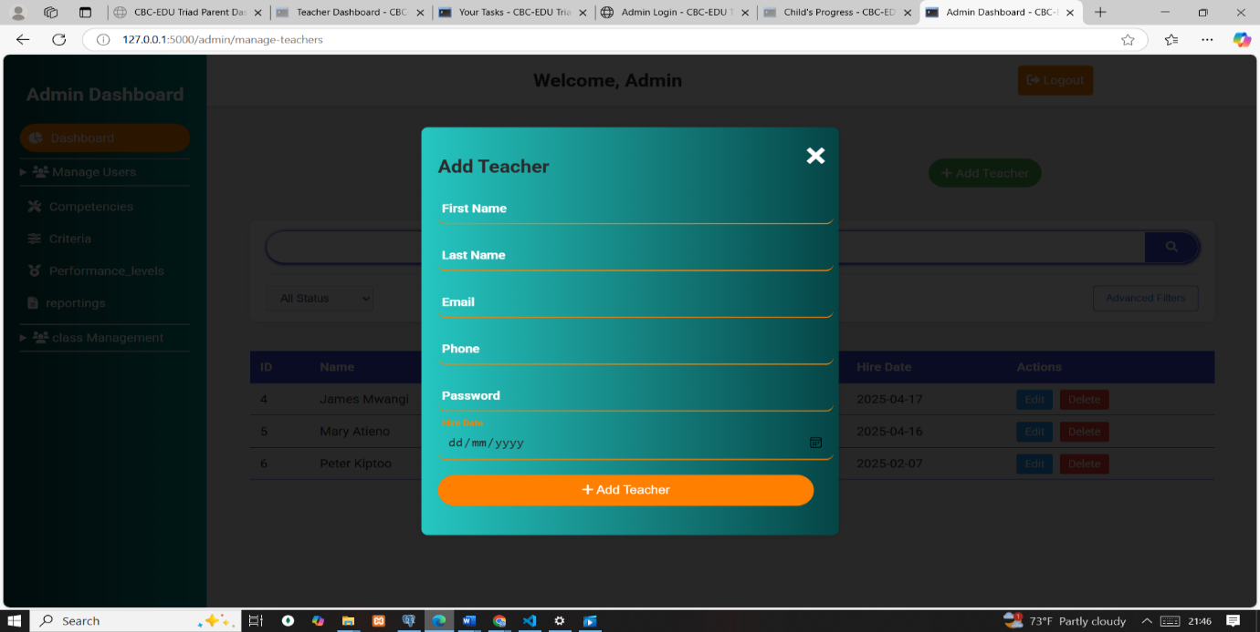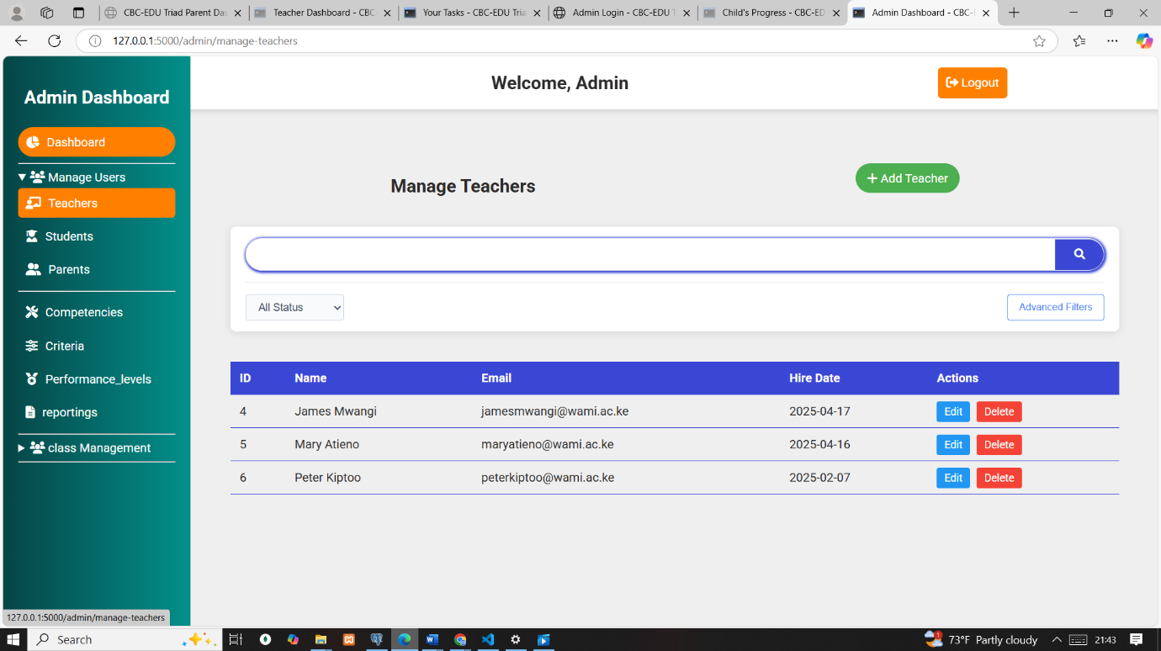Figure :Admin user Management(Teachers)

Figure :Add teacher form

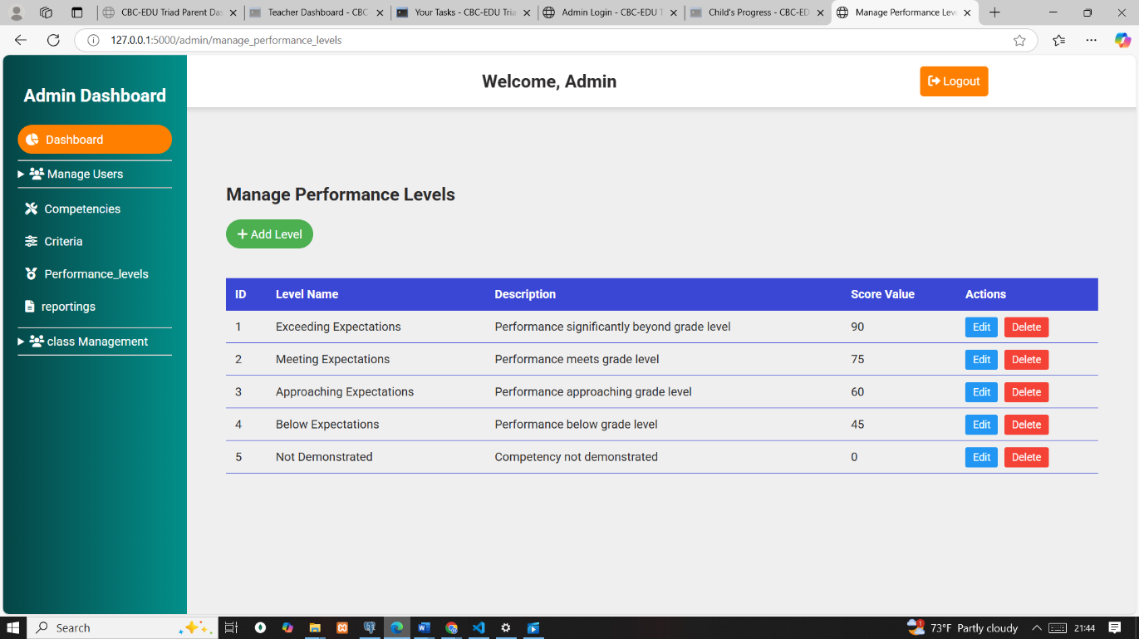Performance level management

Figure :Performance level management

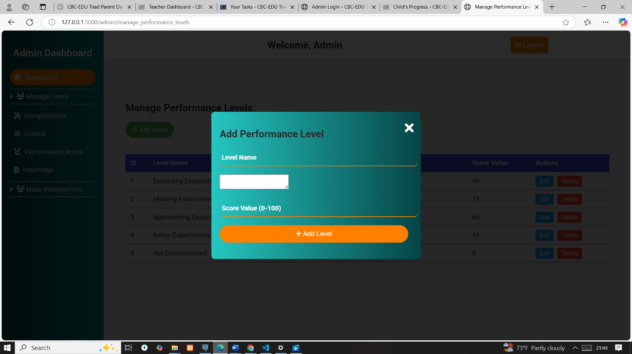

Figure :Performance level modal form

The rest of feature are keeping the same consistent styles

### 6.2.7 Parental Involvement Module

**Parent Login**: Parents log in to access their child's data securely. Only authorized parents can access the information tied to their account.

**Child Selection**: After logging in, parents select which child’s assessment data they want to view. This allows access to specific feedback for the chosen child.

**View Assessment Details**: Parents can see detailed feedback on their child’s assessments:

**Task Title**: The title of the assigned task.

**Competency Name**: The related competency for the assessment.

**General Feedback**: Teacher’s overall feedback for the assessment.

**Performance Levels**: Ratings for each criterion in the assessment.

**Access Control**: Parents can only view data for their own child. The system ensures data privacy by restricting access to other students’ information.

**Competency Feedback**: Parents can view the breakdown of competency feedback with performance levels, helping them understand their child’s strengths and areas for improvement.

**Security**: The system ensures that once the parent is logged in, they can only access information for their child, and once they log out, the session is securely terminated.

## 6.3 Test Plan

This section outlines the test data, test cases, and corresponding results used to validate the CBC-EDU Triad system.

### 6.3.1 Test Data

**Teachers**

|  |  |  |  |  |
| --- | --- | --- | --- | --- |
| First Name | Last Name | Email | Phone | Hire Date |
| James | Mwangi | jamesmwangi@wami.ac.ke | 0746123456 | 2020-01-15 |
| Mary | Atieno | maryatieno@wami.ac.ke | 0746789432 | 2019-05-23 |
| Peter | Kiptoo | peterkiptoo@wami.ac.ke | 0746991200 | 2021-08-10 |
| Lucy | Wambui | lucywambui@wami.ac.ke | 0746345789 | 2022-02-01 |
| David | Odhiambo | davidodhiambo@wami.ac.ke | 0746677889 | 2023-06-18 |

Table :Teachers

**Parents**

|  |  |  |  |  |
| --- | --- | --- | --- | --- |
| **First Name** | **Last Name** | **Email** | **Phone** | **Student Number** |
| Wamie | Wami | wamietech@gmail.com | 0796981288 | STU2023001  STU2023003  STU2023005  STU2023002 |
| John | Uma | uma@gmail.com | 0746998877 |  |
| Esther | Chebet | [estherchebet@yahoo.com](mailto:estherchebet@yahoo.com) | 0746987634 |  |
| Patrick | Karanja | patrickkaranja@gmail.com | 0746776543 | STU2023006 |
| Alice | Akinyi | [aliceakinyi@yahoo.com](mailto:aliceakinyi@yahoo.com) | 0746553344 | STU2023007 |

Table :Parents

**Students**

|  |  |  |  |  |
| --- | --- | --- | --- | --- |
| First Name | Last Name | Email | Phone | Student Number |
| Brian | Otieno | brianotieno@students.wami.ac.ke | 0746001122 | STU2023001 |
| Faith | Wanjiku | faithwanjiku@students.wami.ac.ke | 0746123450 | STU2023002 |
| Kelvin | Kiplangat | kelvinkiplangat@students.wami.ac.ke | 0746345678 | STU2023003 |
| Sheila | Naliaka | sheilanaliaka@students.wami.ac.ke | 0746987654 | STU2023004 |
| Collins | Odongo | collinsodongo@students.wami.ac.ke | 0746234567 | STU2023005 |

Table :Students

**Competencies**

|  |  |
| --- | --- |
| Competency Name | Competency Description |
| Communication and Collaboration | Ability to express ideas clearly and work effectively with others |
| Critical Thinking and Problem Solving | Ability to analyze situations and develop appropriate solutions. Identifies root cause before proposing solutions |
| Creativity and Imagination | Ability to generate innovative ideas and approaches |
| Digital Literacy | Ability to use digital tools effectively for learning |

Table :Competencies

**Criteria**

Breaks down each competency into specific measurable behaviours

|  |  |  |
| --- | --- | --- |
| Competency Name | Criteria Name | Criteria Description |
| Communication and Collaboration | Oral Communication | Ability to express ideas clearly in speech |
| Communication and Collaboration | Teamwork | Ability to work effectively in a group setting |
| Critical Thinking and Problem Solving | Problem Analysis | Ability to break down problems into components |
| Critical Thinking and Problem Solving | Solution Development | Ability to develop appropriate solutions |
| Creativity and Imagination | Idea Generation | Ability to come up with original ideas |
| Creativity and Imagination | Innovation Implementation | Ability to implement creative solutions |
| Digital Literacy | Tool Usage | Ability to use digital tools effectively |
| Digital Literacy | Information Evaluation | Ability to assess digital information critically |

Table :Criteria

**Classes**

|  |  |  |  |
| --- | --- | --- | --- |
| **Class Name** | **Teacher Name** | **Academic Year** | **Created At** |
| **Grade 6** | **James Mwangi** | **2025** | **_** |
| **Grade 7** | **Mary Atieno** | **2025** | **_** |
| **Grade 8** | **—** | **—** | **—** |
| **Grade 9** | **—** | **—** | **—** |

Table :Classes

**Class and Students**

|  |  |  |  |
| --- | --- | --- | --- |
| **Class Name** | **Student Name** | **Student Number** | **Enrollment Date** |
| Grade 6 | Brian Otieno | STU2023001 | 2024-01-12 |
| Grade 6 | Faith Wanjiku | STU2023002 | 2024-01-12 |
| Grade 6 | Collins Odongo | STU2023005 |  |
| Grade 7 | Kelvin Kiplangat | STU2023003 | 2024-01-12 |
| Grade 7 | Sheila Naliaka | STU2023004 | 2024-01-12 |

Table :Class and Students

**Student Groups**

|  |  |  |
| --- | --- | --- |
| **Group Name** | **Created By (Teacher Name)** | **Created At** |
| Team Alpha | James Mwangi | 2024-01-15 09:00:00 |
| Team Beta | Mary Atieno | 2024-01-15 09:05:00 |
| Team Gamma | James Mwangi | 2024-01-15 09:10:00 |
| Team Delta | Mary Atieno | 2024-01-15 09:15:00 |

Table :Student Groups

**Performance Levels**

|  |  |  |
| --- | --- | --- |
| Level Name | Level Description | Score Value |
| Exceeding Expectations | Performance significantly beyond grade level | 90 |
| Meeting Expectations | Performance meets grade level | 75 |
| Approaching Expectations | Performance approaching grade level | 60 |
| Below Expectations | Performance below grade level | 45 |
| Not Demonstrated | Competency not demonstrated | 0 |

Table :Performance Levels

### 6.3.2 Test Cases and Results

**Test Case 1: Parent Student Linking**

A parent that hasn’t been linked to a student on the Parent Dashboard can’t get data for any student. Select options are empty. A parent with 4 children logged in and was able to have the option to select from their available students to monitor. When a child was selected, the corresponding result for that student were the one displayed.

Test Result 1

Unlinked parent sees no student to select or data displayed (PASS)

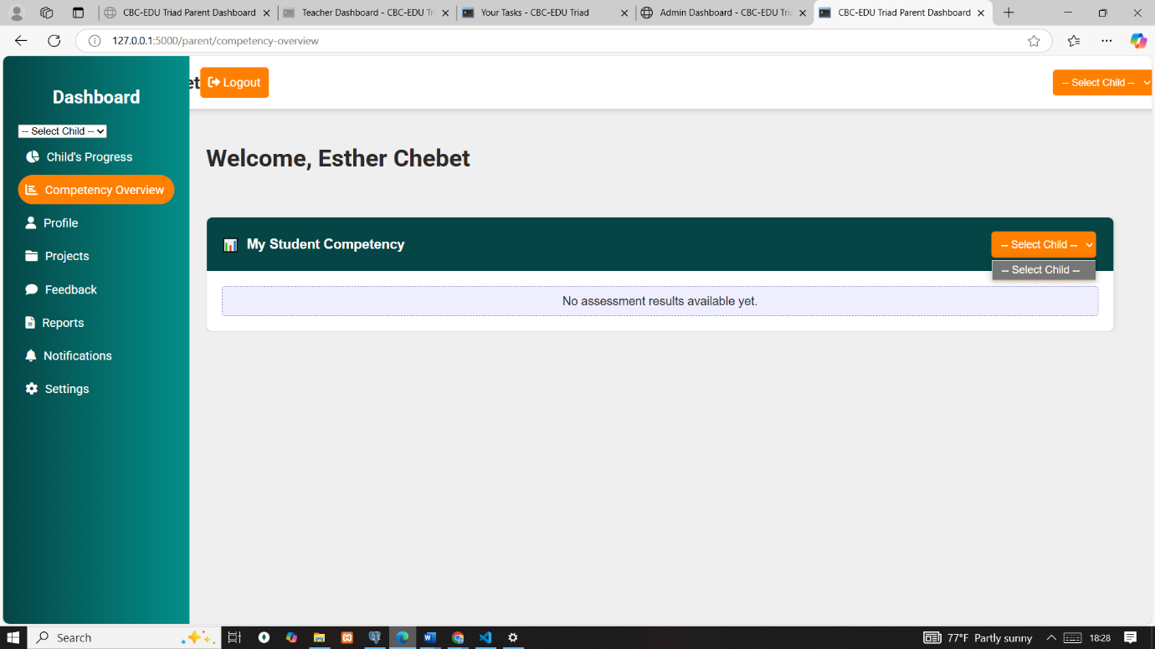

Figure :parent with no linked student

Linked parent can switch between student profiles at top right corner and see the correct data (PASS)

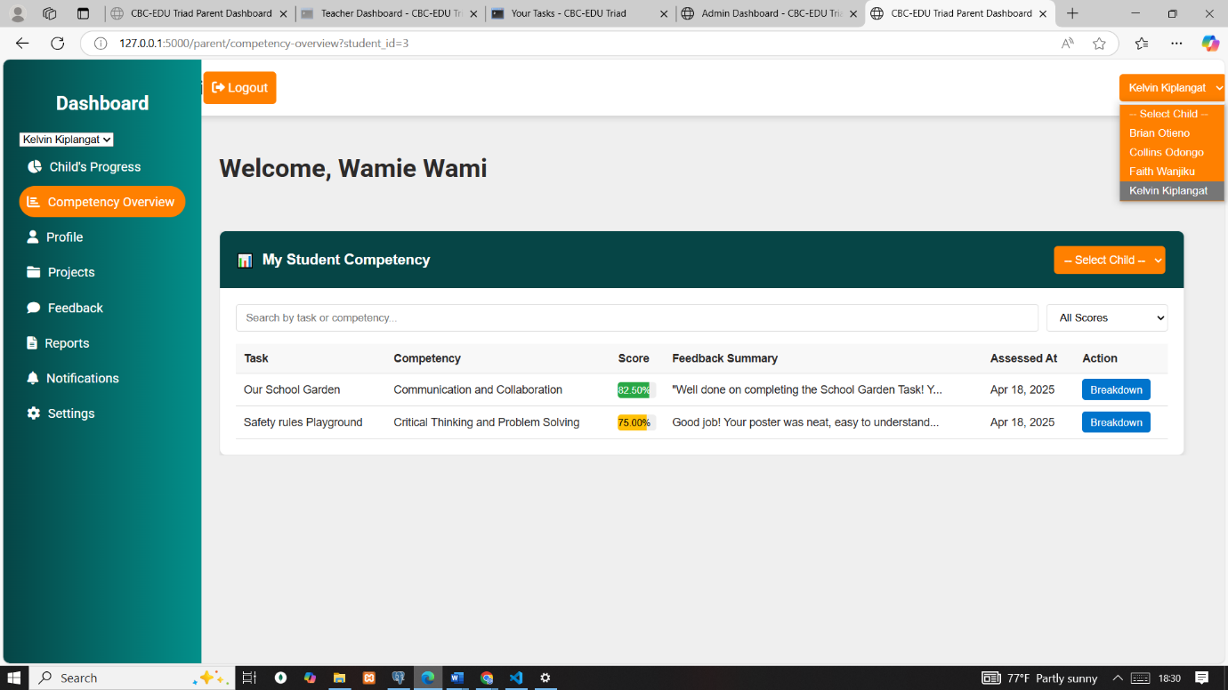

Figure :Linked parent and student

**Test Case 2: RBAC (Role-Based Access Control)**

A parent who is in the system tries to input correct credentials to penetrate the admin dashboard. Credentials are valid, but the role is ‘Parent’, not ‘Admin’.

**Test Result 2**

Red warning displayed: “You do not have permission to access this page.” (PASS)

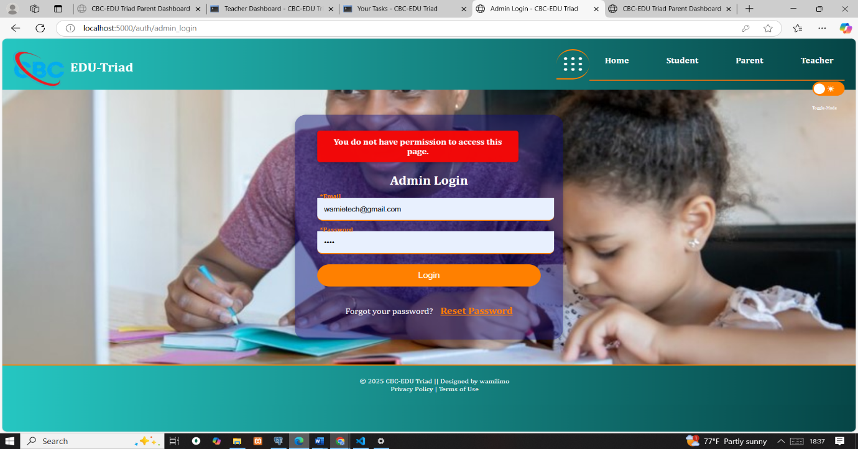

Figure :Role-Based Access Control error

**Test Case 3: Mapping and Tracking a Competency**

While assigning a task, the teacher mapped a competency to that task. The exact competency is the one that was tracked and assessed.

**Test Result 3**

The system correctly bind the task to the competency upon assessment the mapped competency was the one to be assessed (PASS)

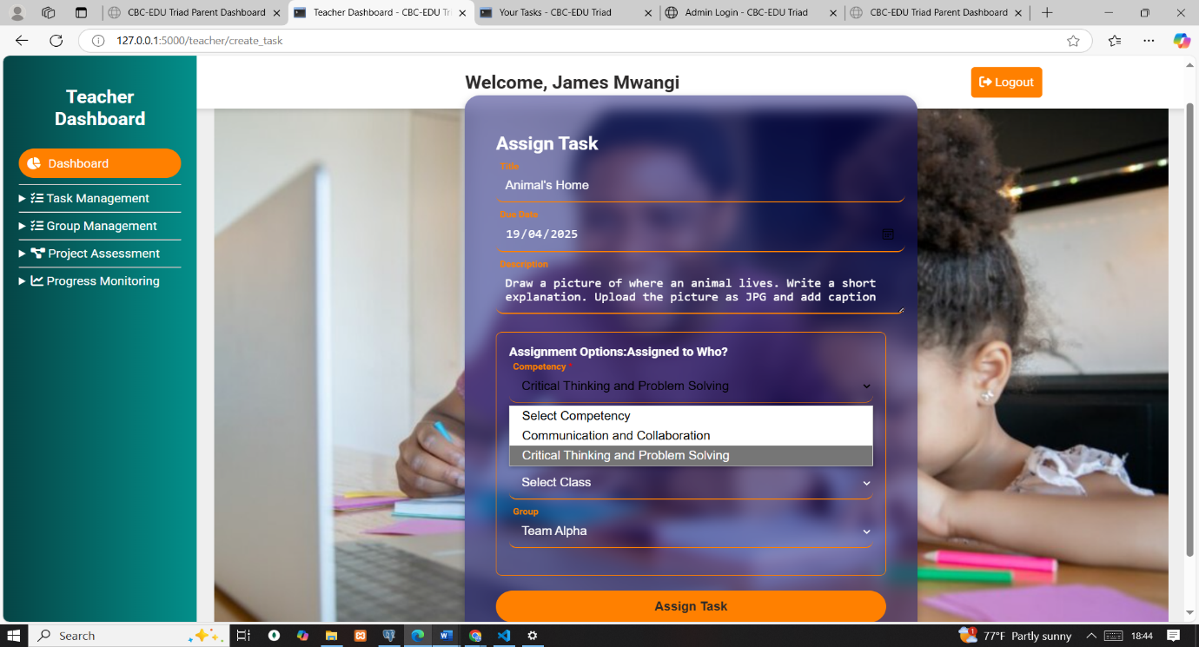

Figure :Mapping a competency to task

Teachers were able to track submission status if submitted or not (PASS)

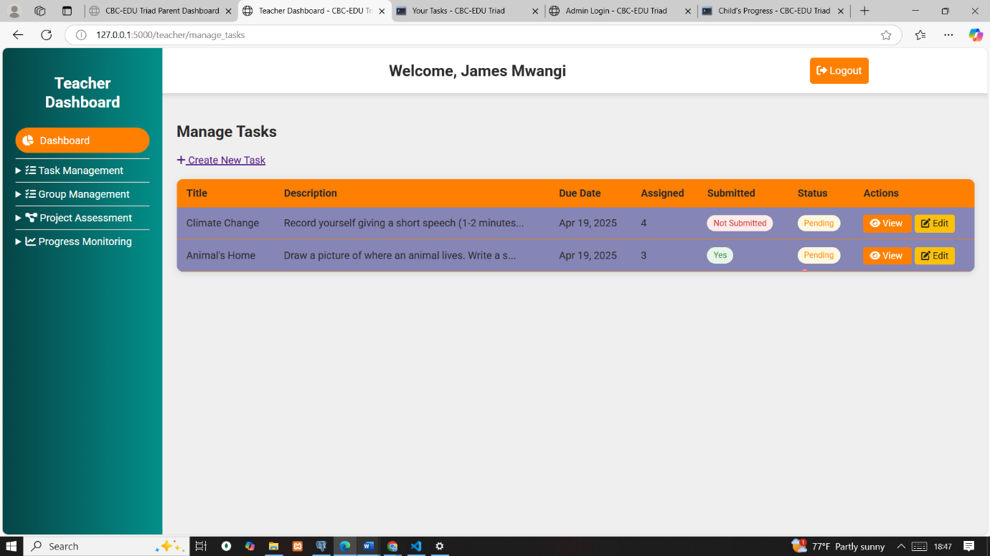

Figure :The task and submission status

The mapped competency critical thinking and problem solving at assessment was tracked (PASS)

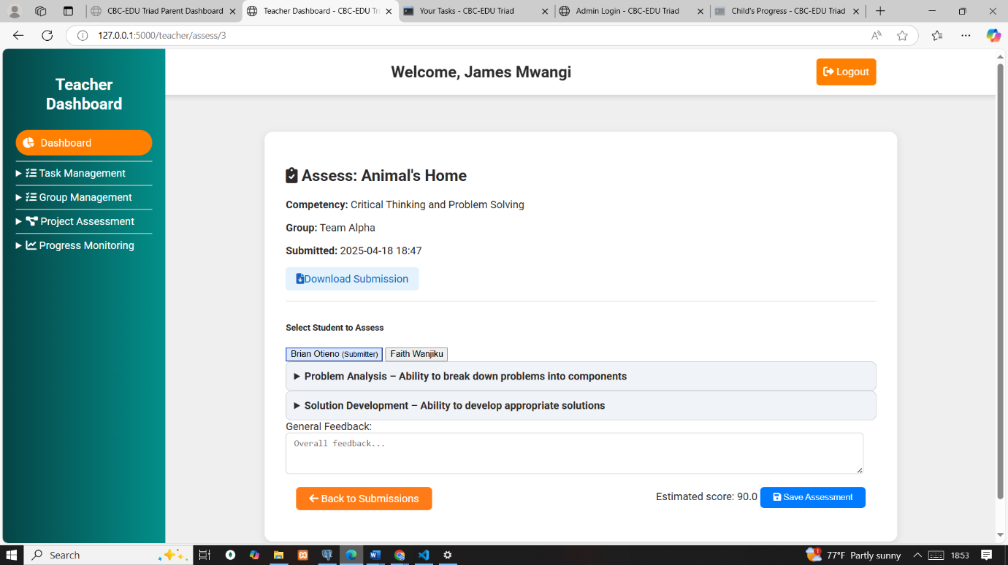

Figure :mapped competency critical thinking and problem solving

**Test Case 4: Correct Tracking of Criteria to Designated Competency**

At assessment, the correct criteria were dynamically fetched for that specific competency. If "Critical Thinking" was selected, only criteria for it were available .

Test Result 4

Relevant criteria shown only for the selected competency (PASS)

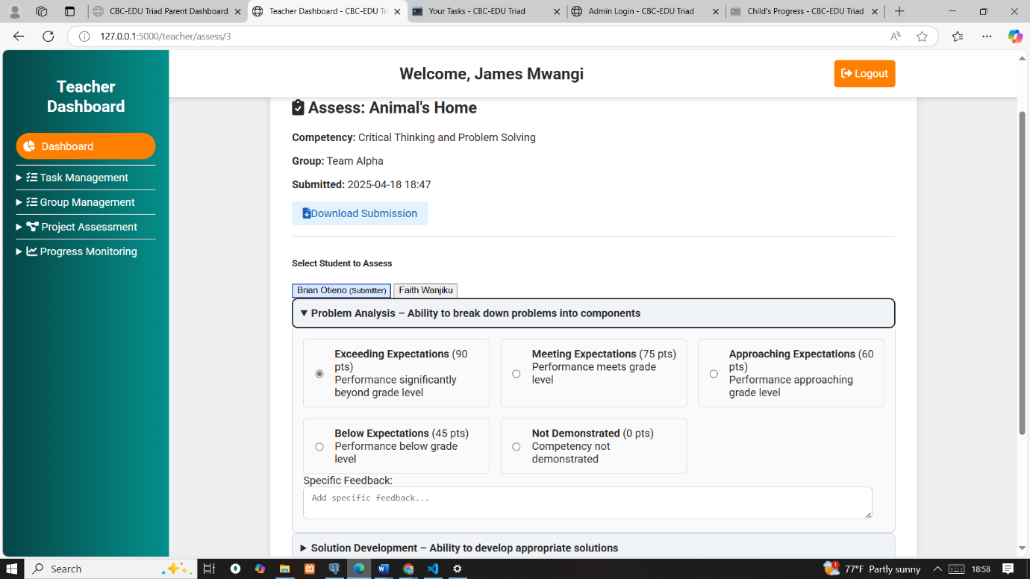

Figure :Only Relevant criteria for competency

**Test Case 5: Task for Assignee’s View**

Verified that the task assigned to the student is shown only to that student in the portal. No other user can view it. Indicators: red (overdue), blue (pending), green (submitted). Submission button is disabled after submission.

Test Result 5

Only assigned student could view the task (PASS)

Indicators functioned as expected: red, blue, green (PASS)

Figure :Student1 view their assigned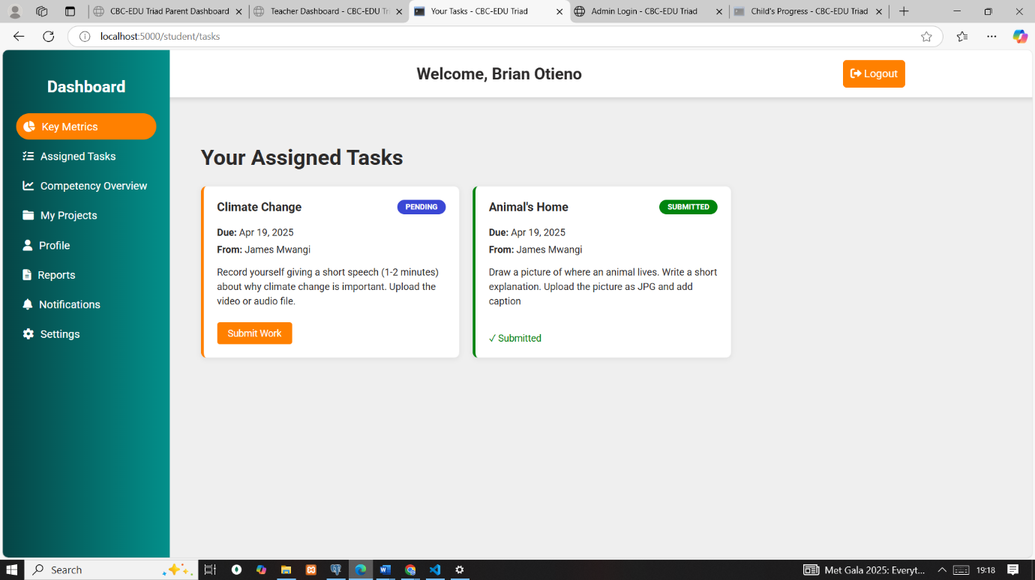

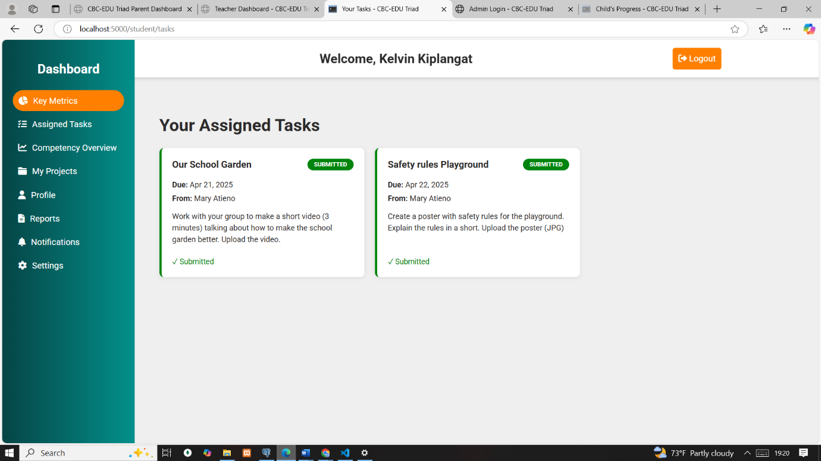

Figure :Student1 view their assigned

**Test Case 6: Teacher Gets Submission**

Teacher was able to see the task they assigned, with clear labels and ready for assessment. Teachers could not view submissions from tasks assigned by another teacher.

Test Result 6

Submission visibility was role-based and limited to the teacher who assigned it (PASS)

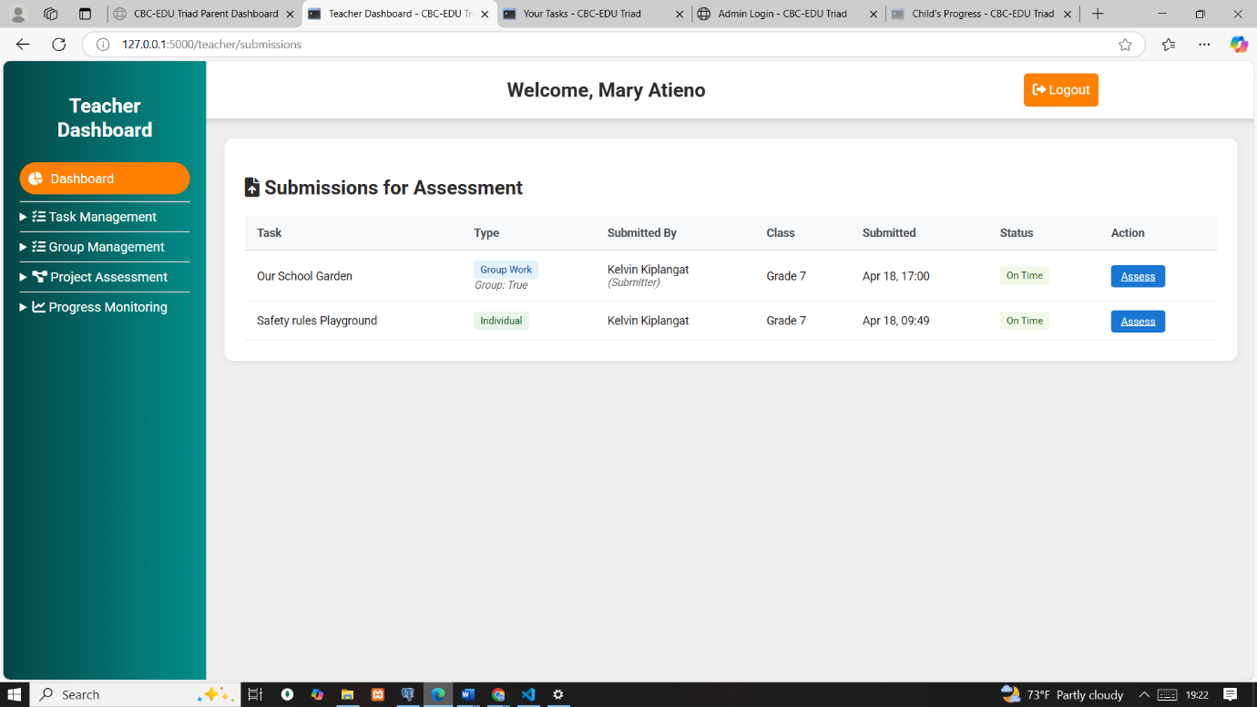

Figure :Teacher 1 get submissions

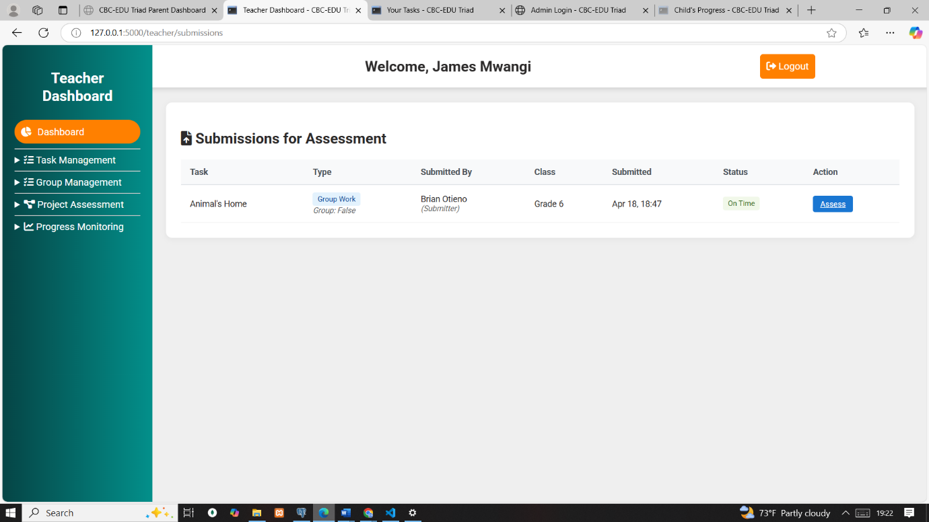

Figure :Teacher 2 get submissions

**Test Case 7: Rubric Assessment and feedback**

Teachers were able to download the exact file from download button view and start assessment. The system fetches rubric criteria linked to the assigned competency and prepopulate for teacher to assess using criteria dynamically fetched. Criteria defined the average level of the competency, assessment and results send to student and the parent.

Test Result 7

Criteria fetched dynamically based on rubric and matched competency and assessment well done. Student assessed could see their feedbacks and were able to see how criteria evaluated the competency  (PASS)

Figure :Student 1 results and feedbacks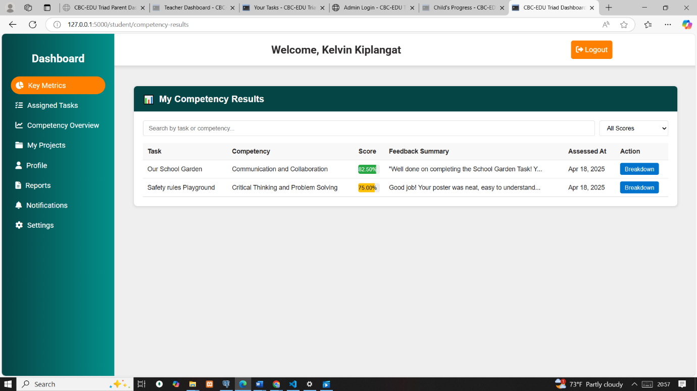

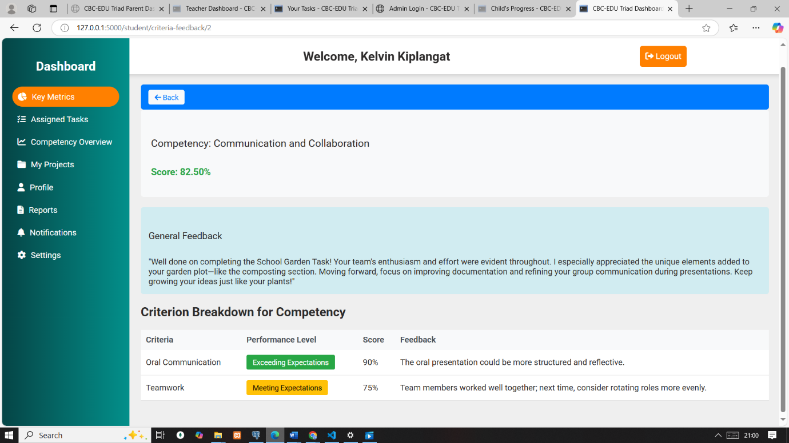

Figure :Feedback criteria breakdown

Test case 8 Email verification and password resets

Unverified emails were redirected to verify email with warning, until verified to login. Emails send to the recipient with correct instruction. Various users reset their password on clicking the links, several parents verified their email and were able to login

Test result 8

Emails well send to indented user and verified; password well reset by unique token. PASS

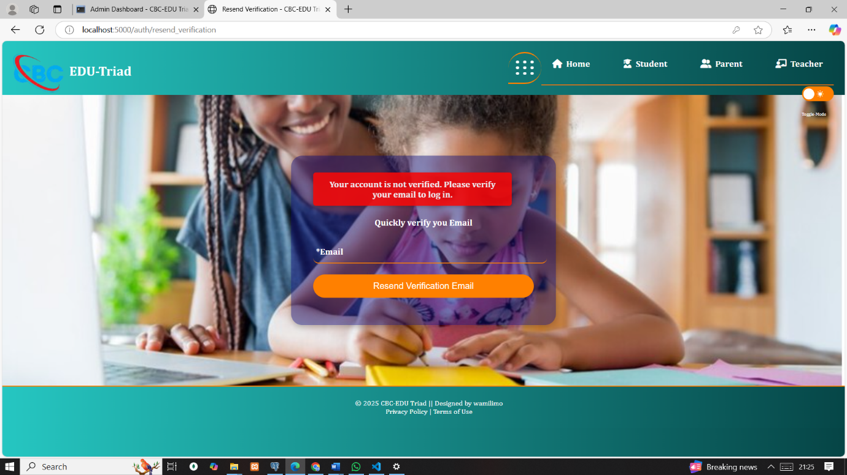

Figure :verify email to login

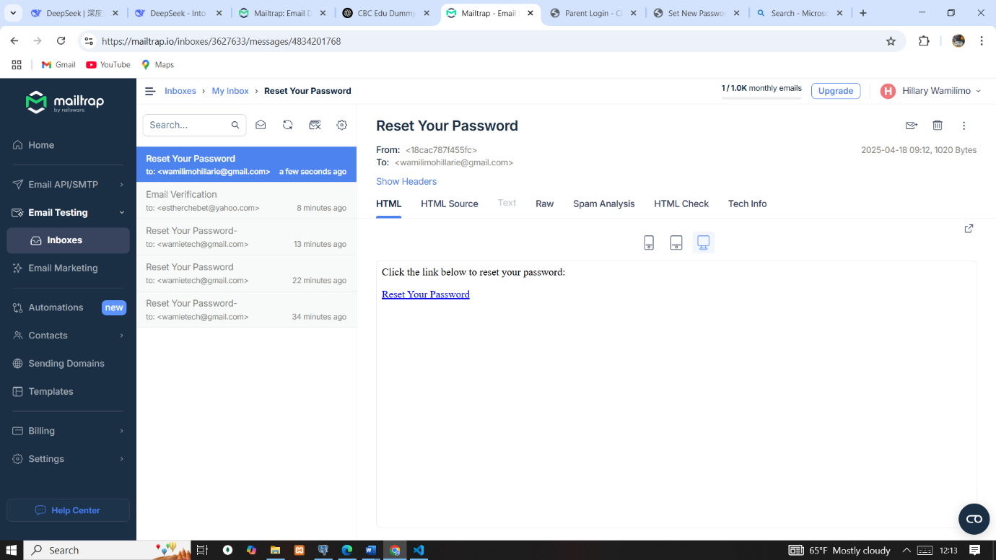

Figure :mailtrap inbox email testing

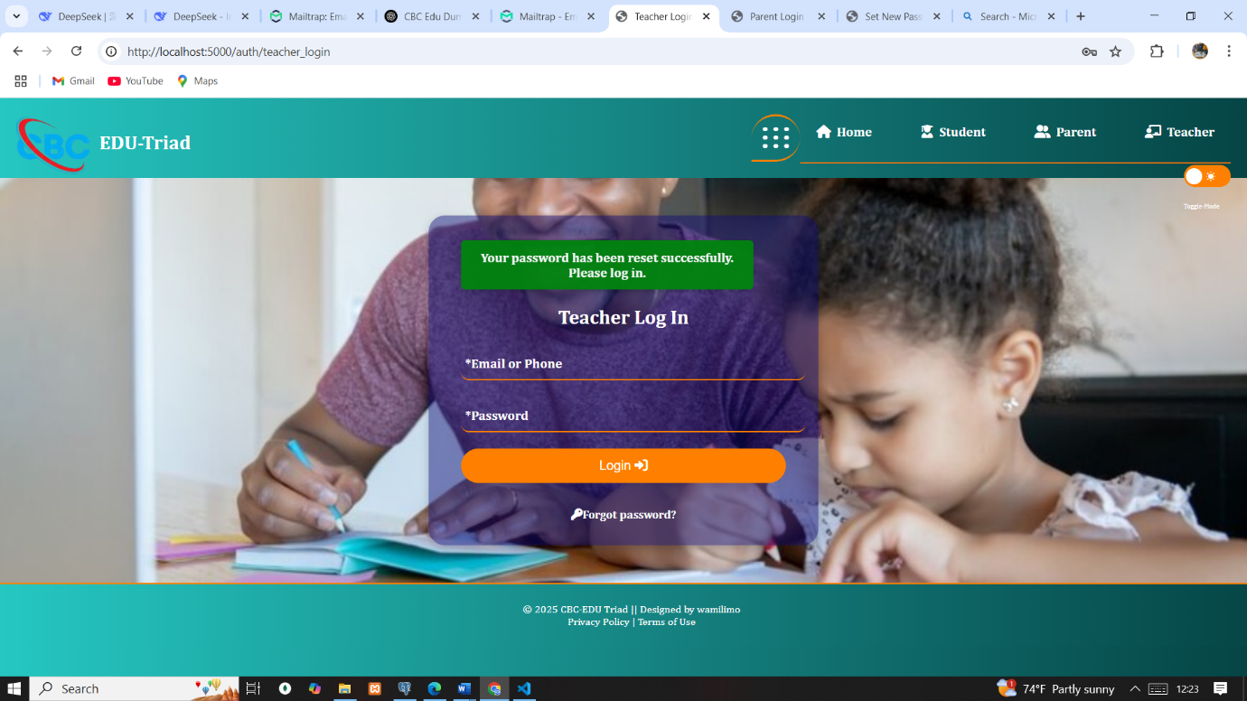

Figure :Password securely changed

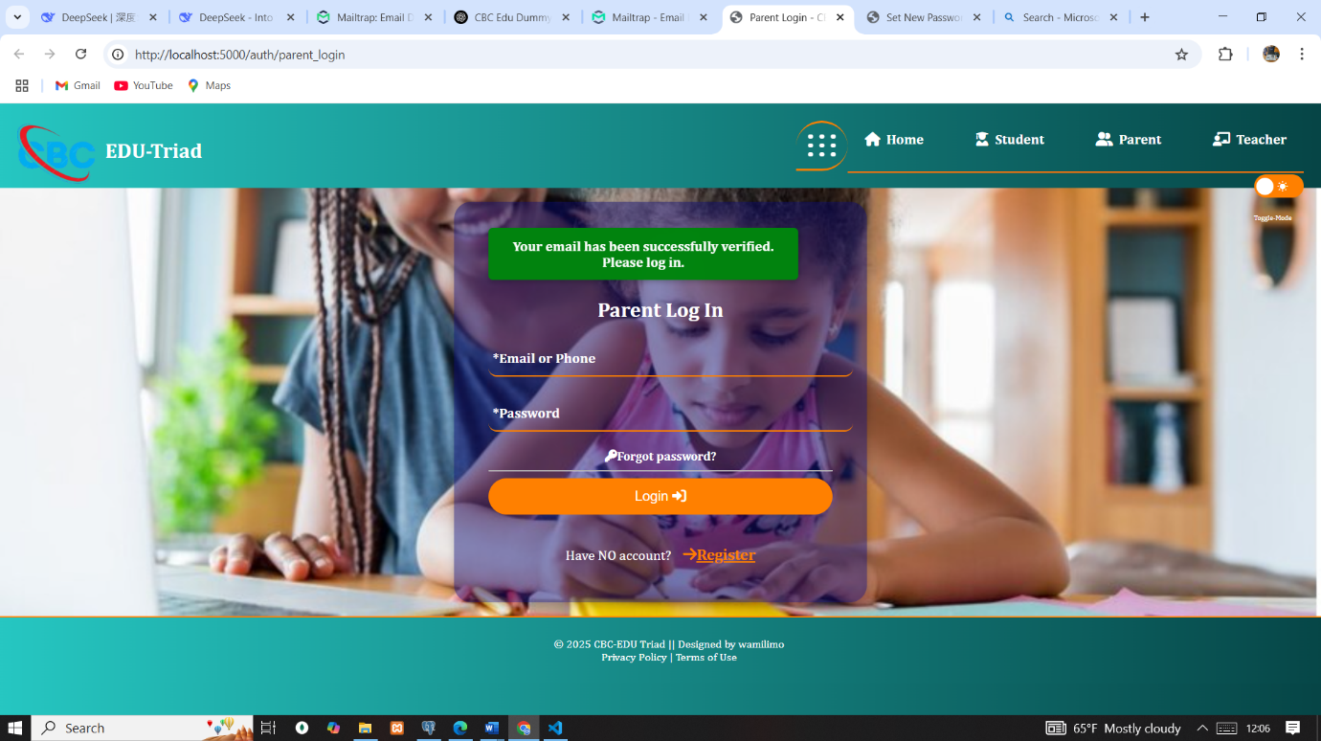

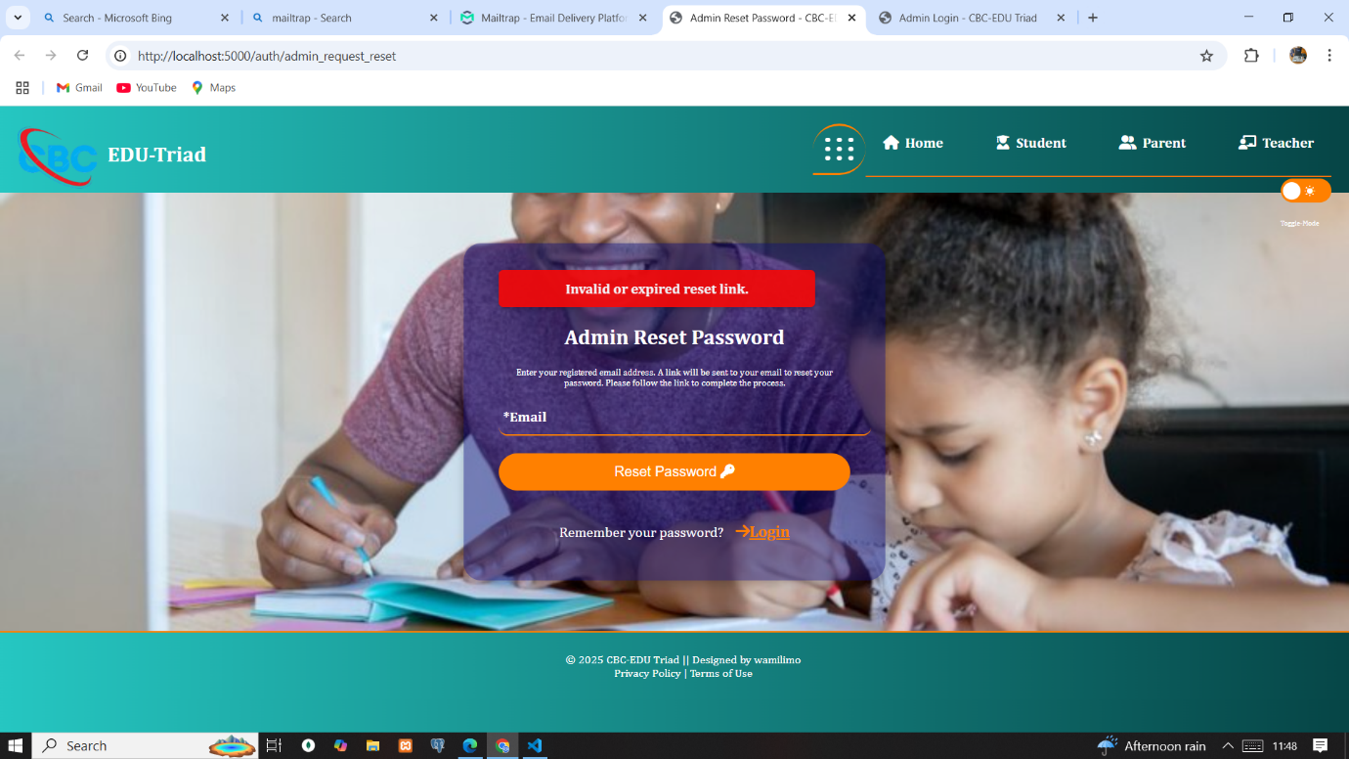Figure :verified emails

Figure :Invalid token/ expired token

Test case 9: User management and competencies

Admin was able to edit the profiles of users with form pre populated with right user data including verifying the account, competencies linking with criteria, criteria and performance etc.

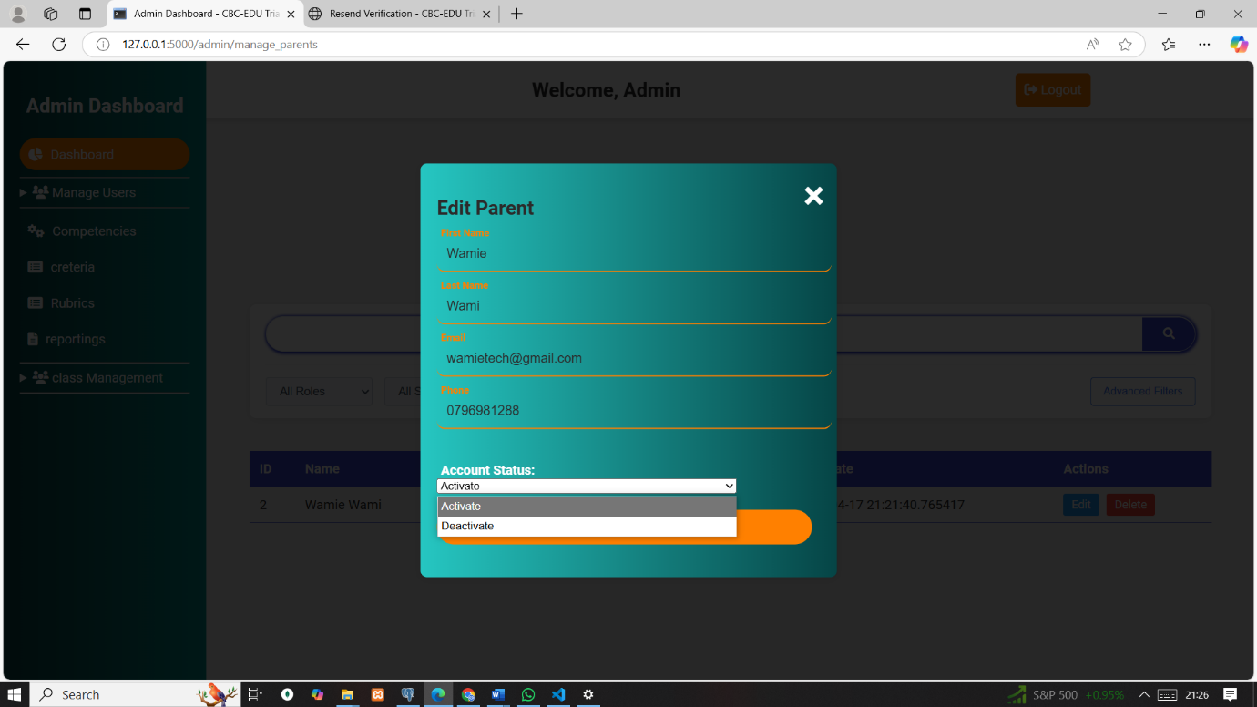

Figure :Edit and activate user account

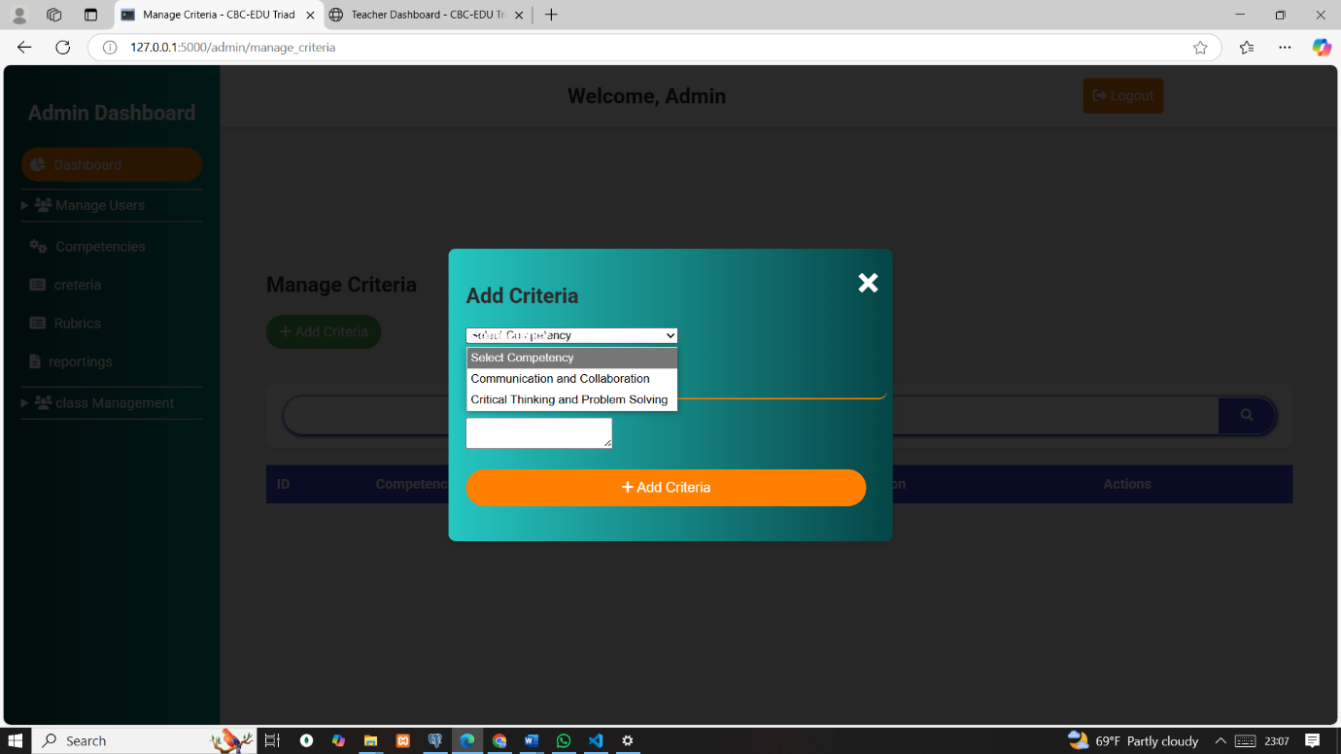

Figure :Add criteria

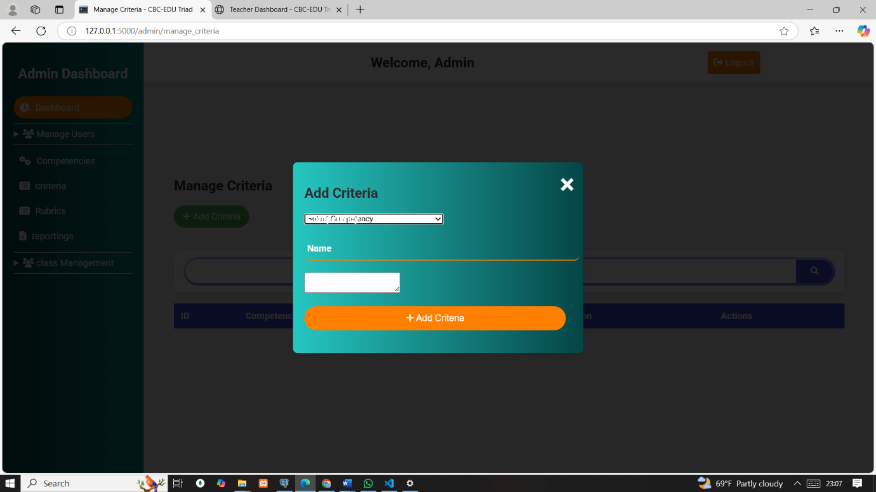Figure :add criteria

Test case 10: Data integrity in adding student to a class

Each student could belong to **only one class at a time**, enforcing academic structure and data integrity. Once a student was added to a class, they were dynamically removed from the list of available students during subsequent class assignments, preventing duplicate allocations. (PASS)

Test result 9

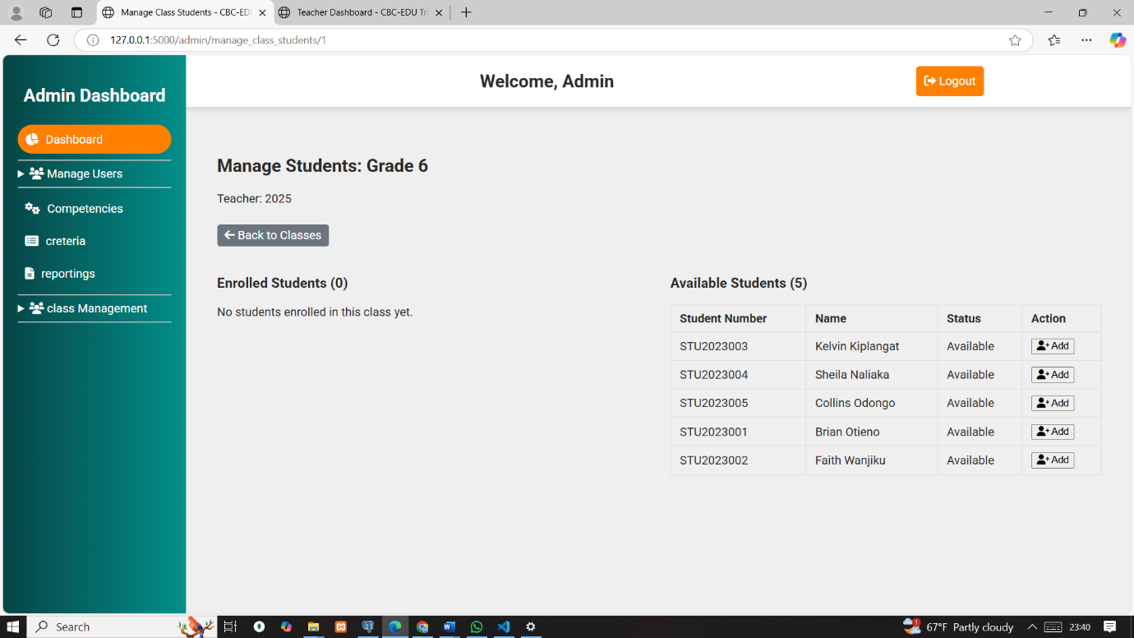

Figure :Before added to class

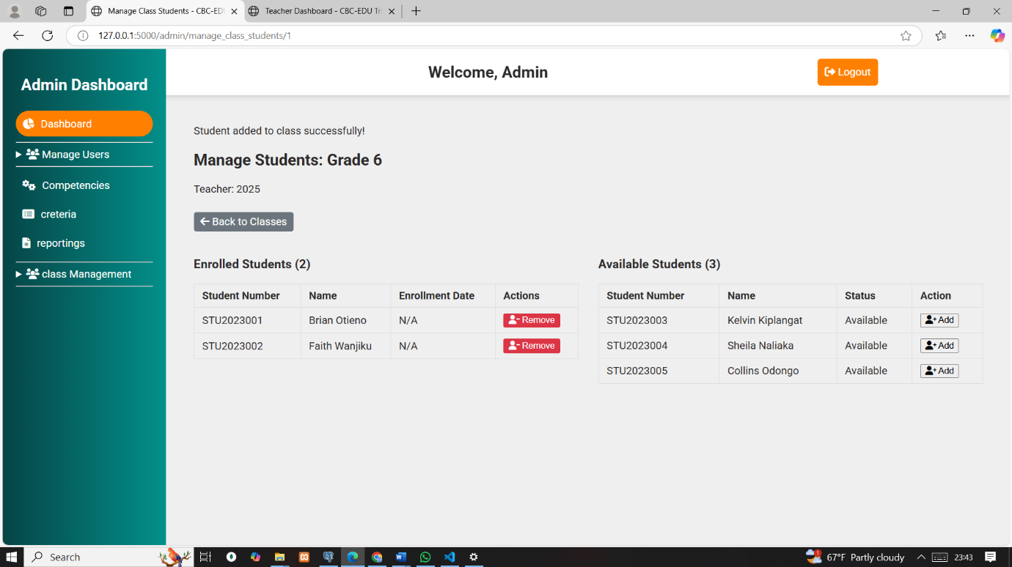

Figure :After added to a class

## 6.4 Database Implementation

The database was implemented in PostgreSQL using SQL statements based on the proposed design. Data was added to test the structure using UI forms, and queries were run to confirm everything works as expected. Screenshots attached.

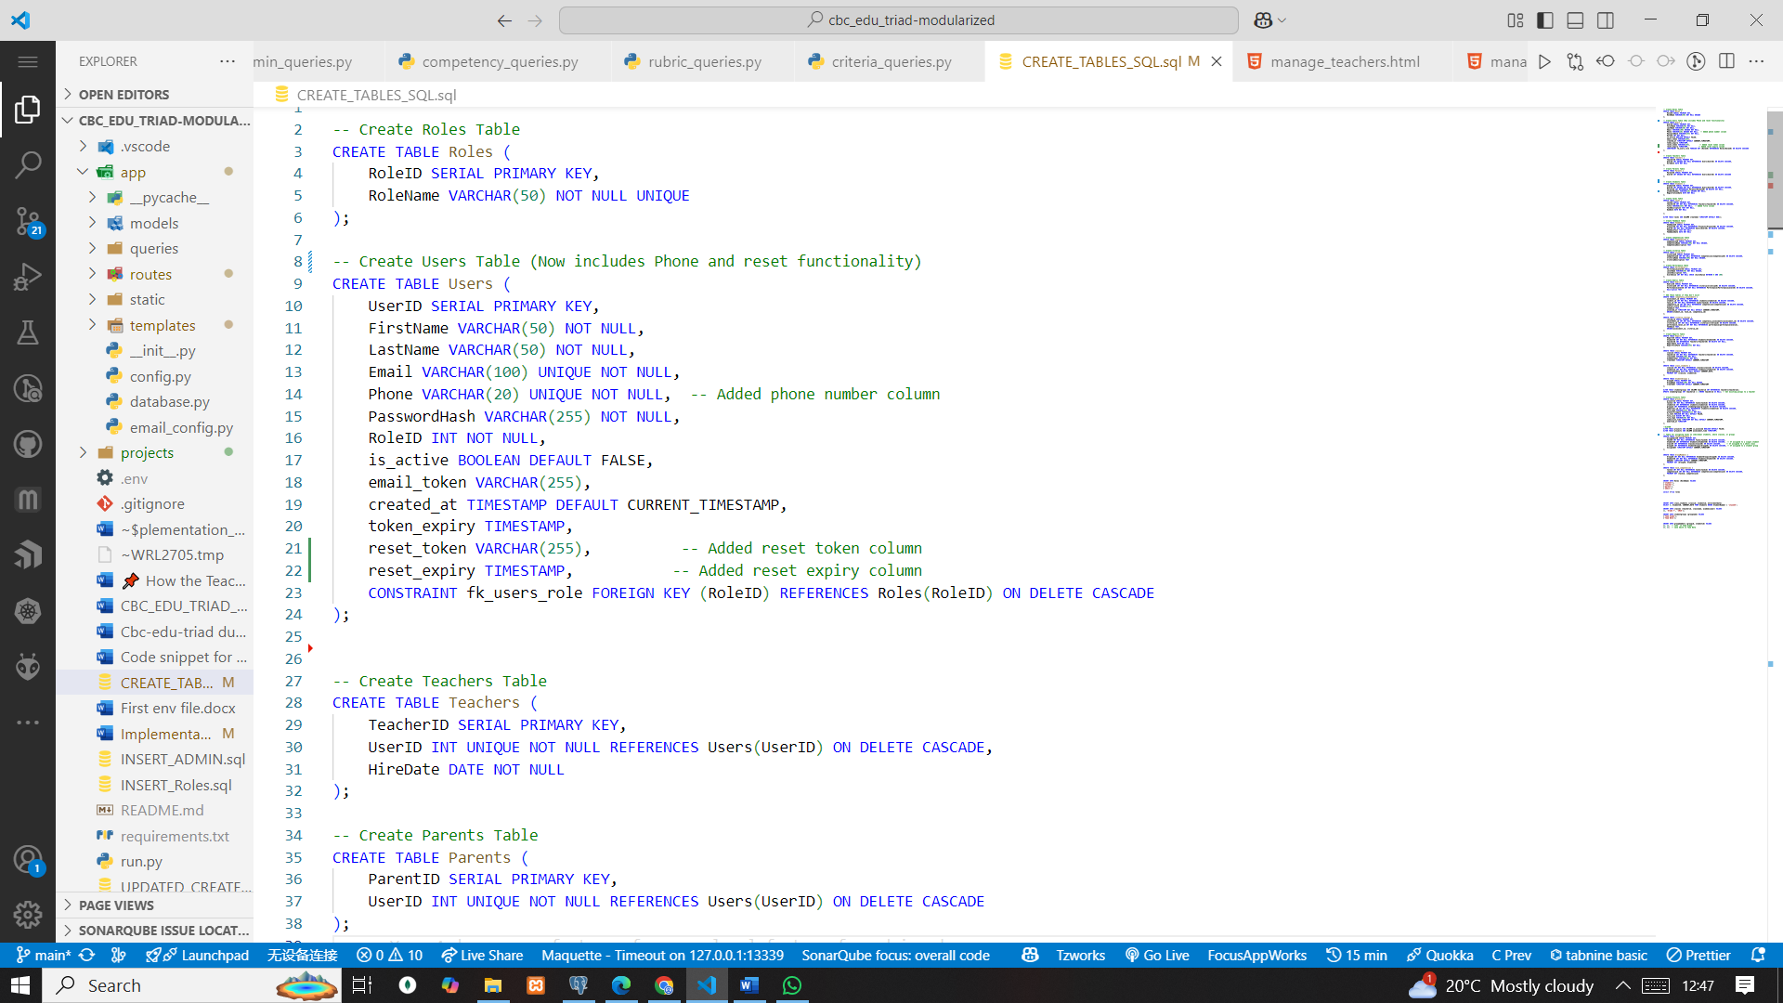

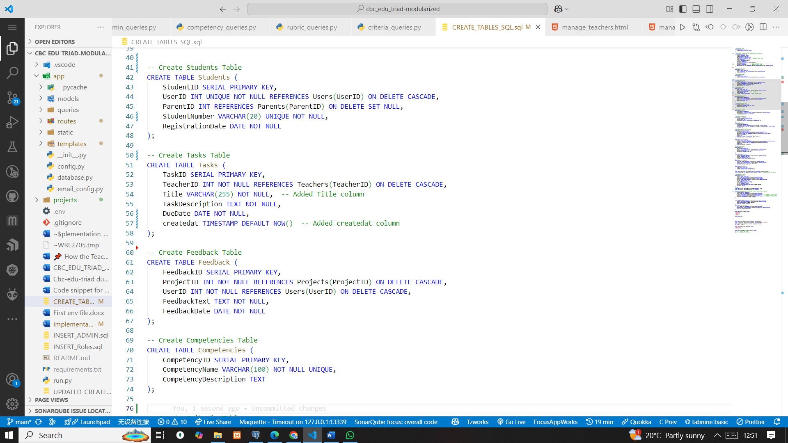

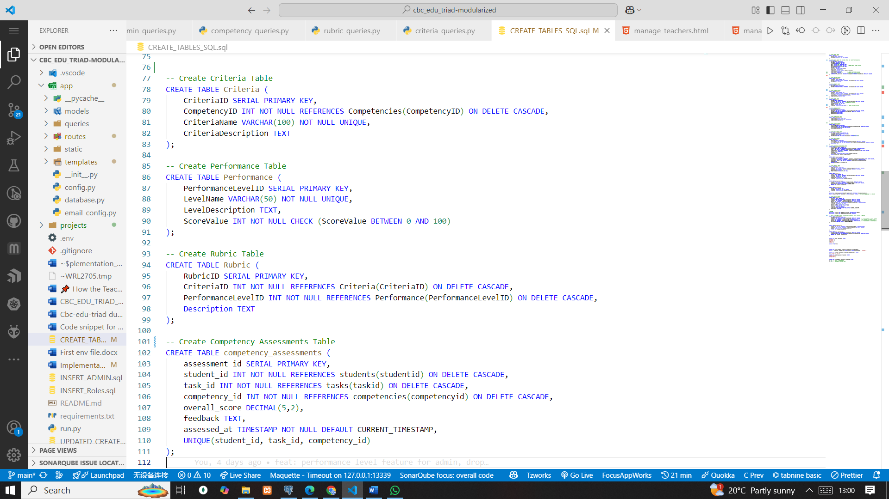

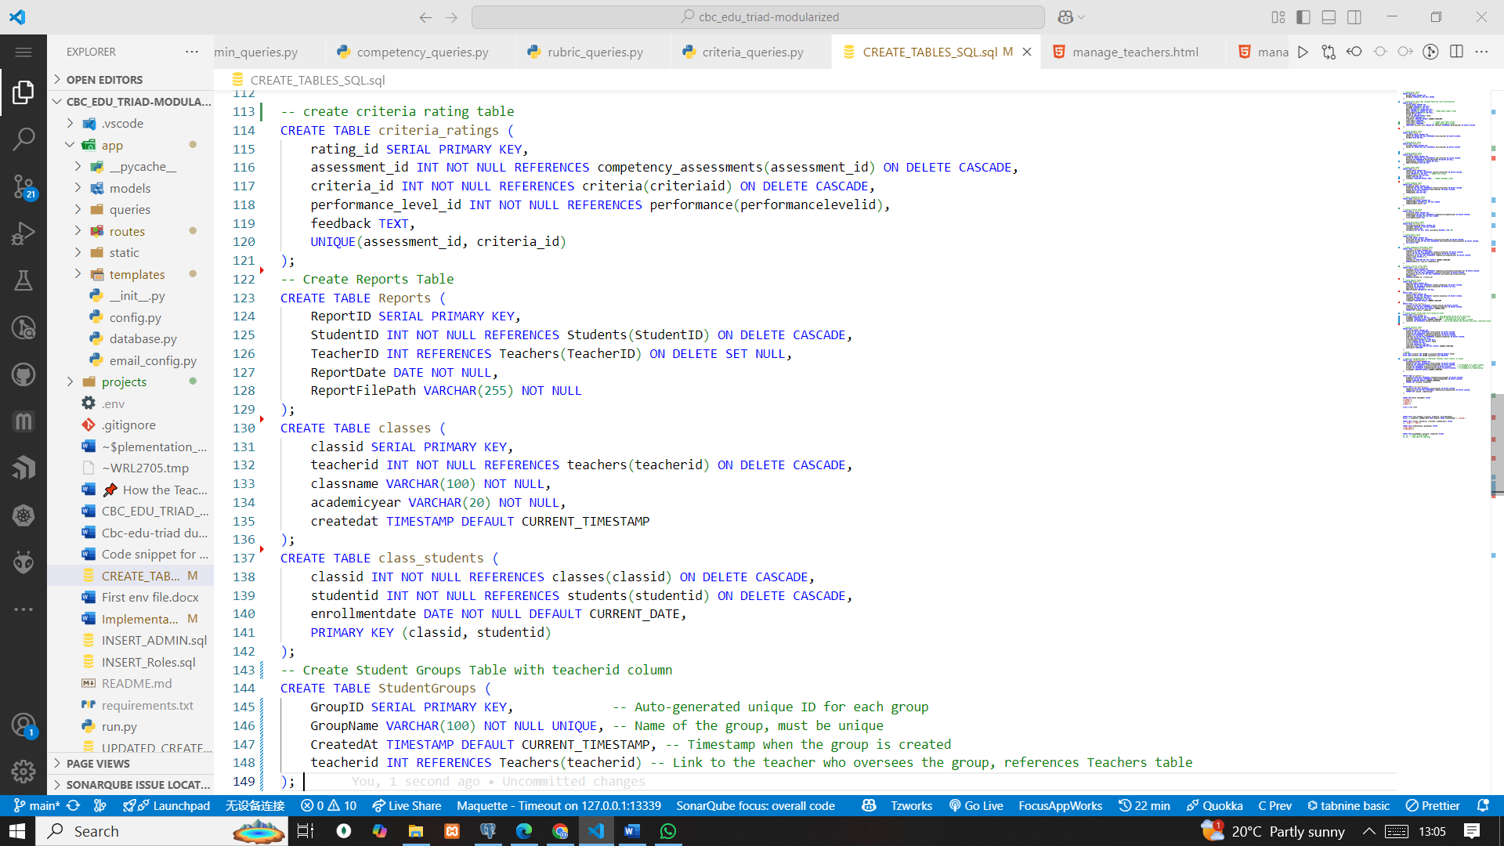

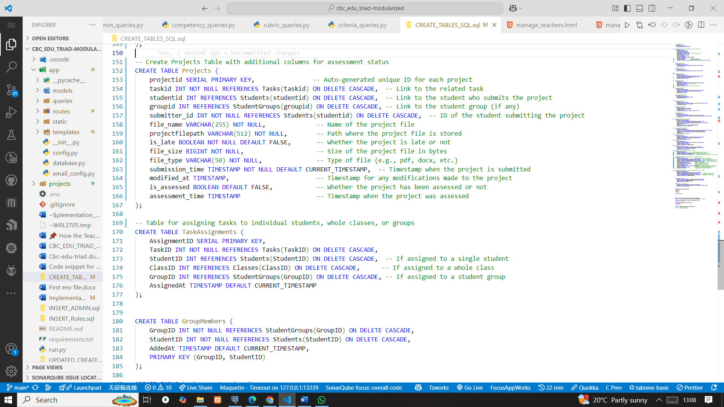

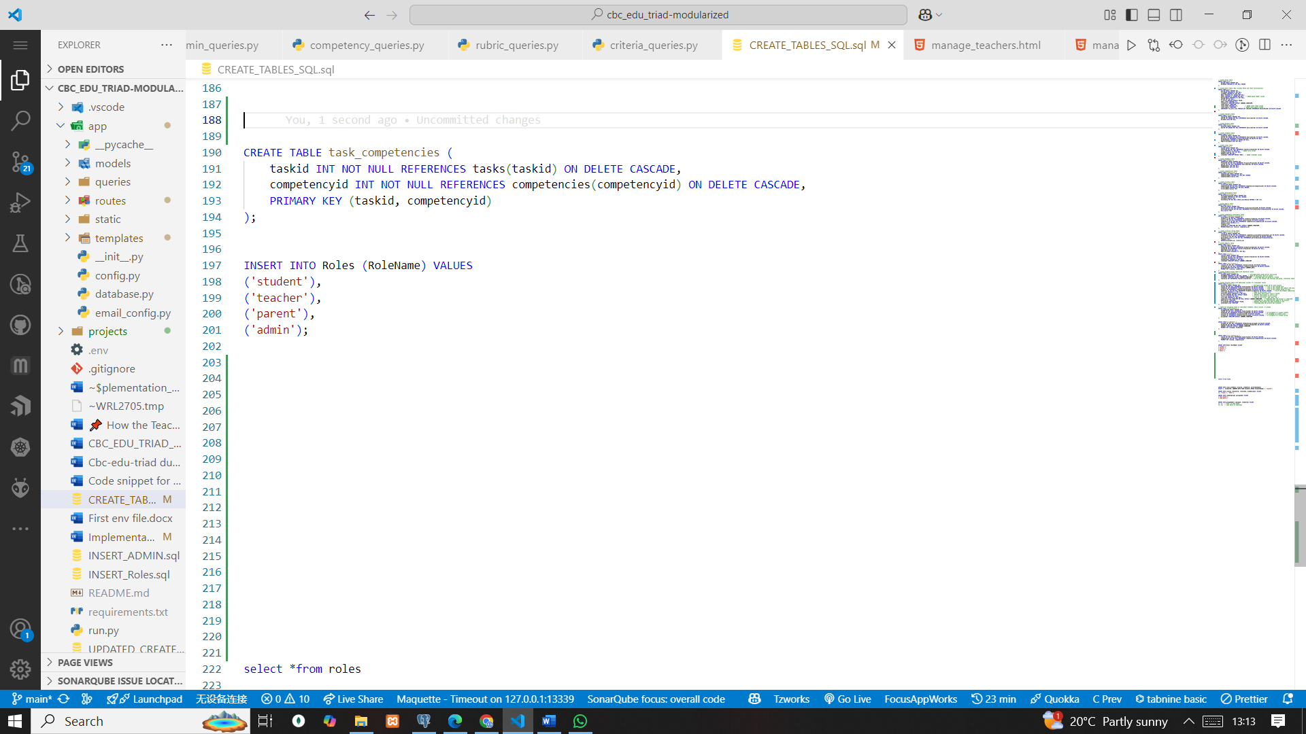

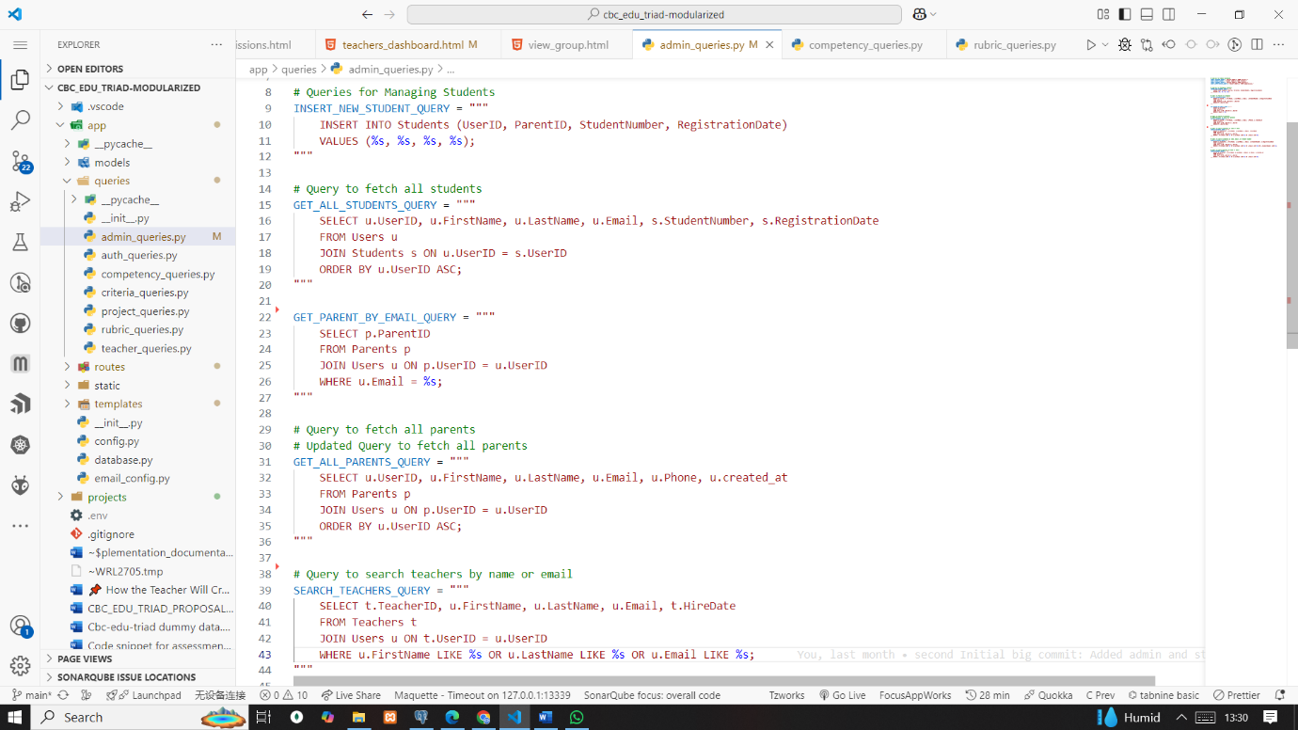Admin queries

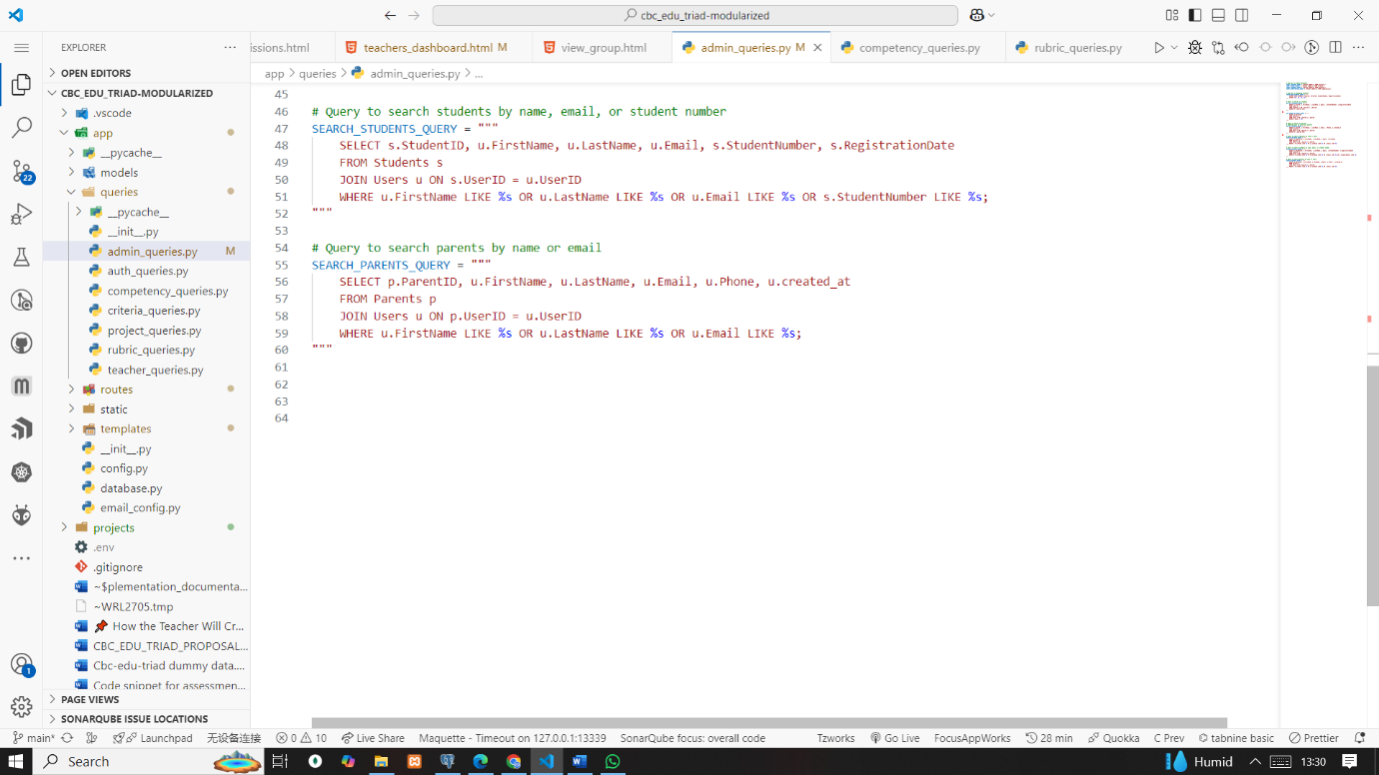

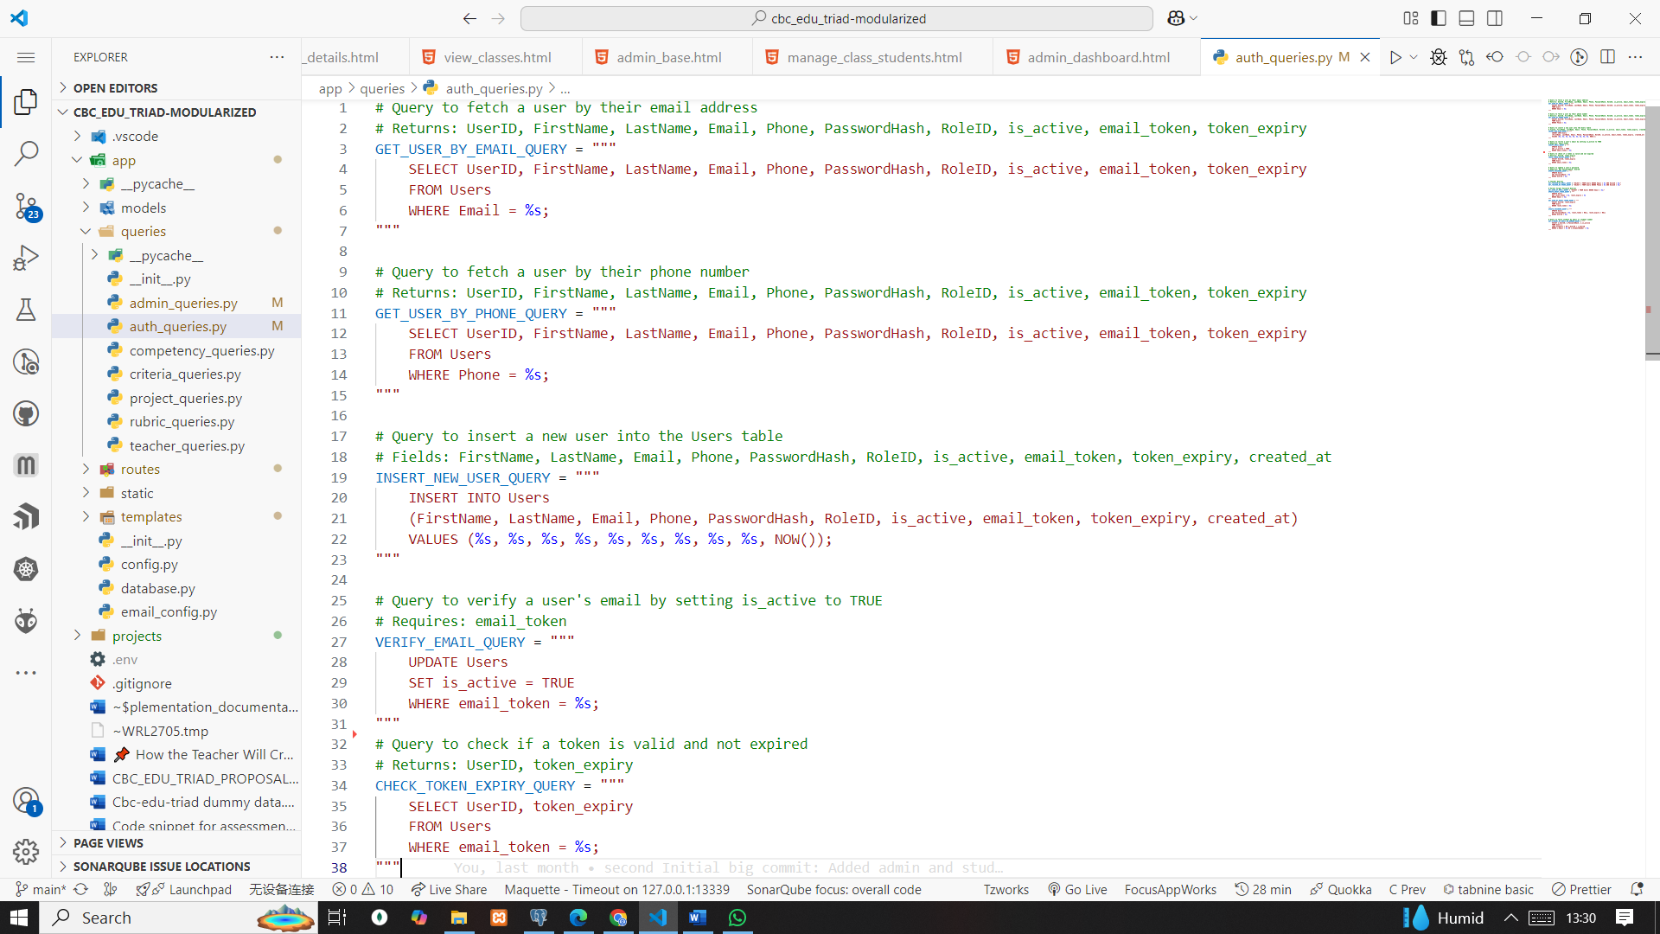Auth queries

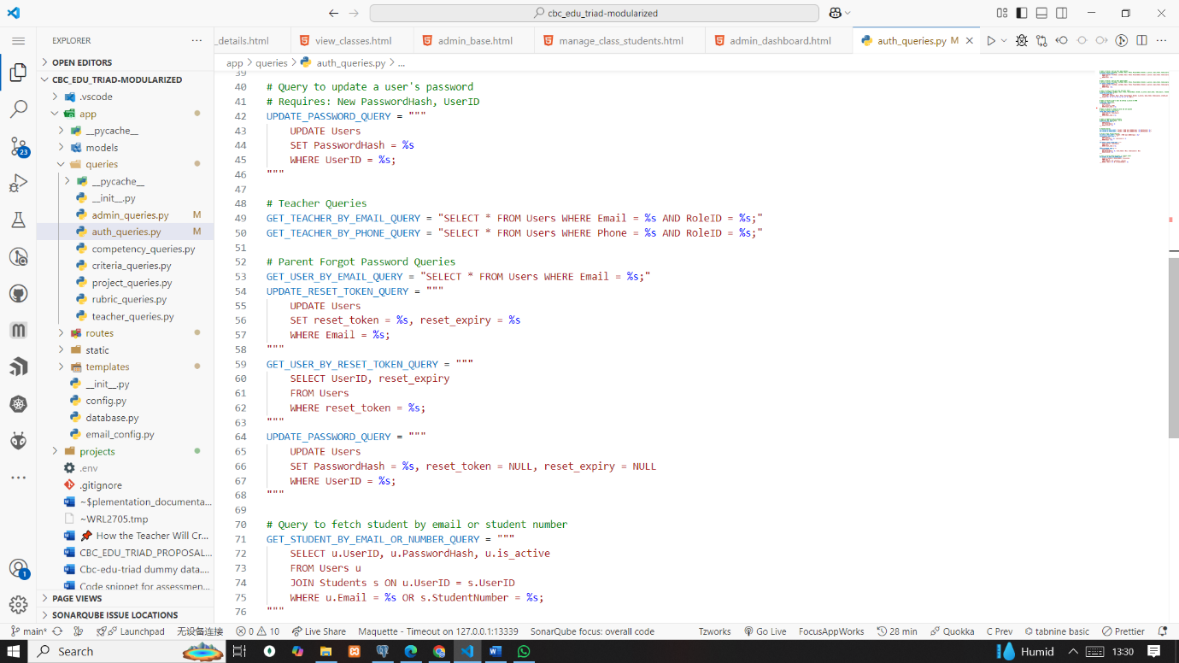

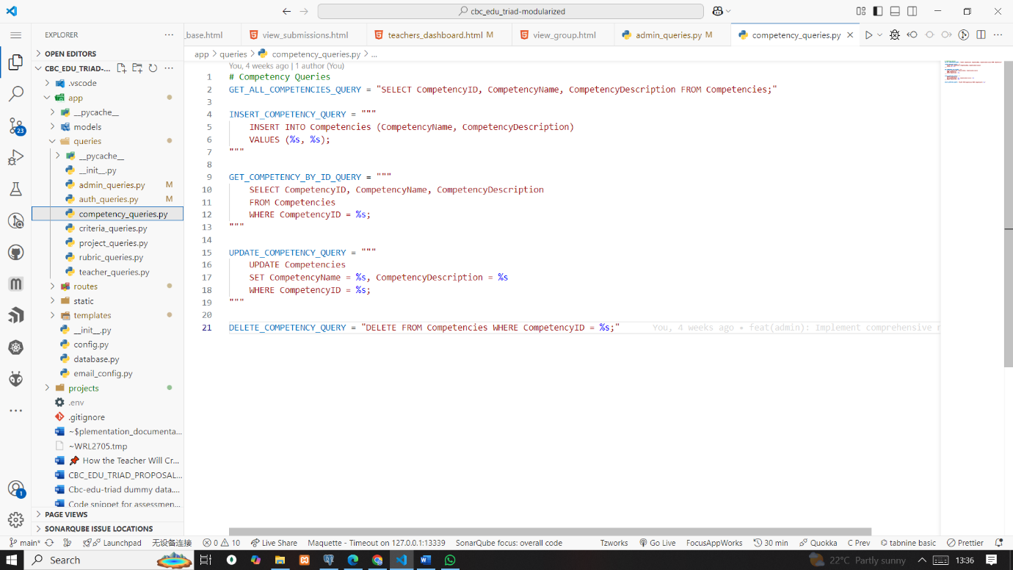Competencies queries and criteria

# 

projects queries 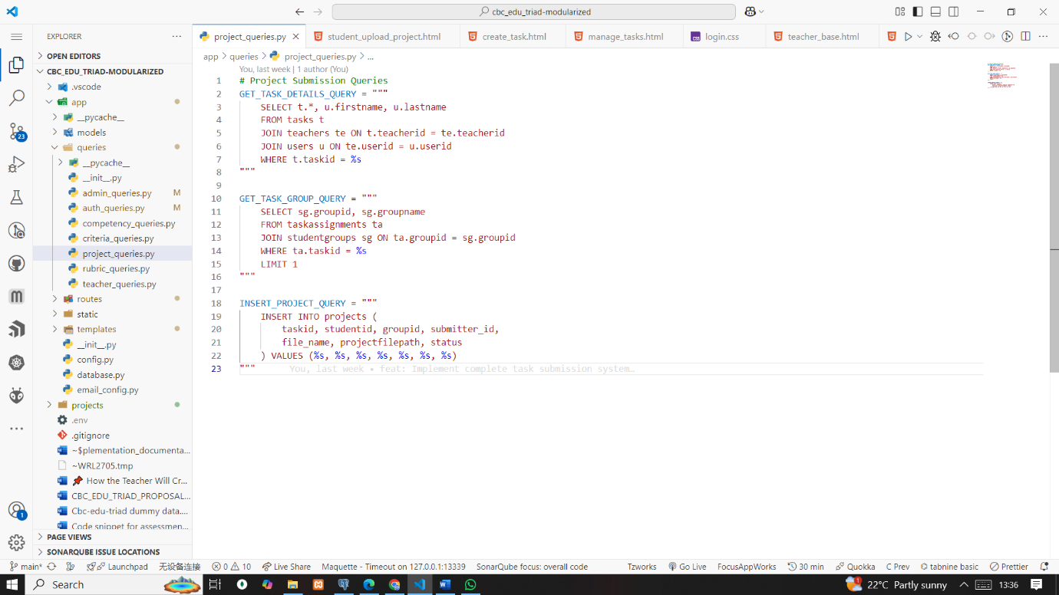

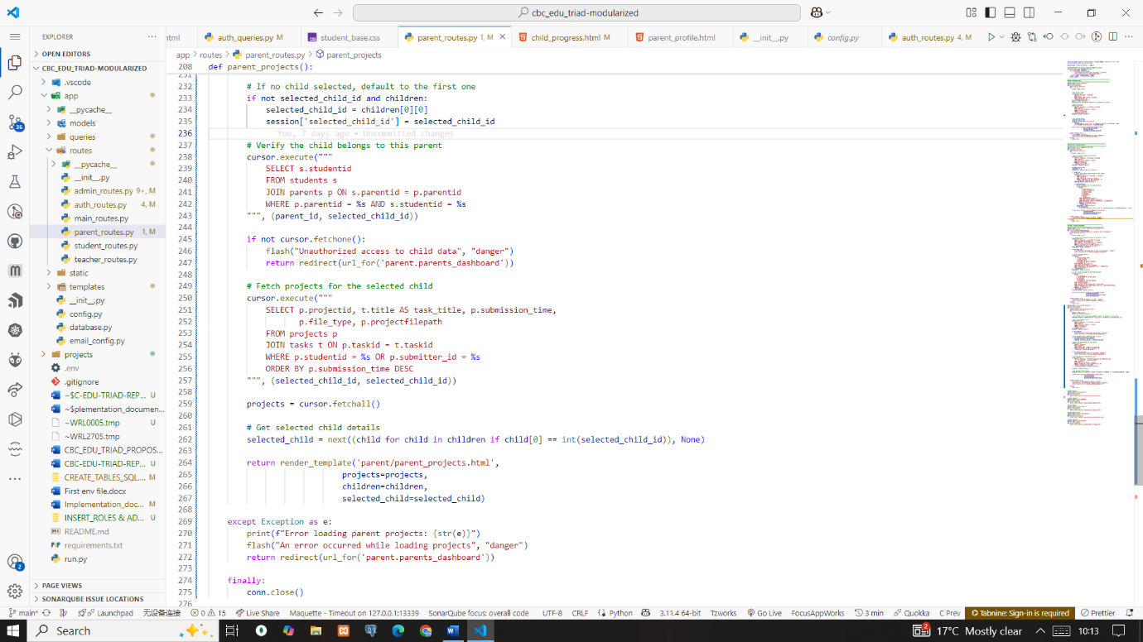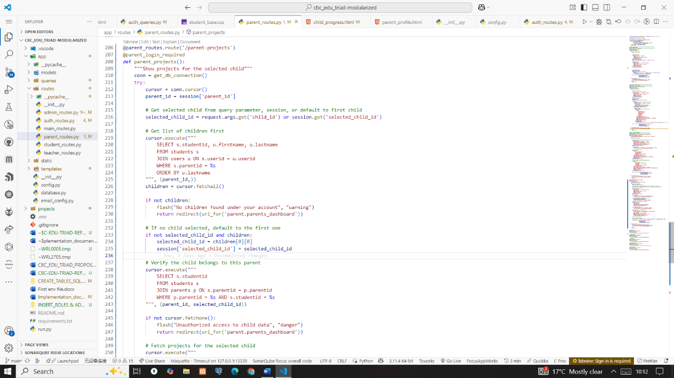

Backend for fetching student to respective parent

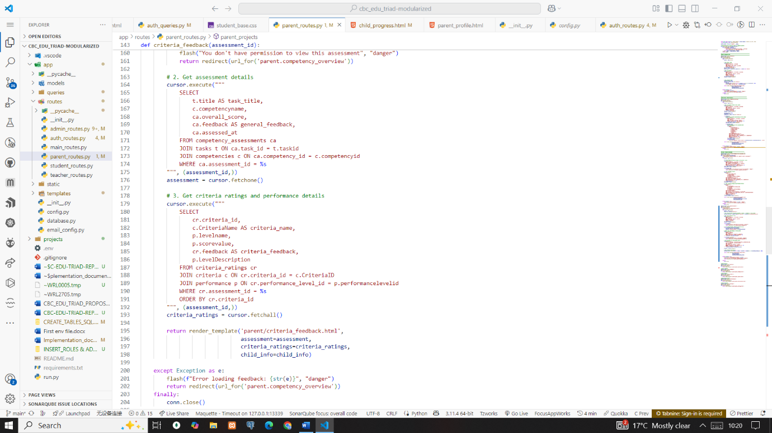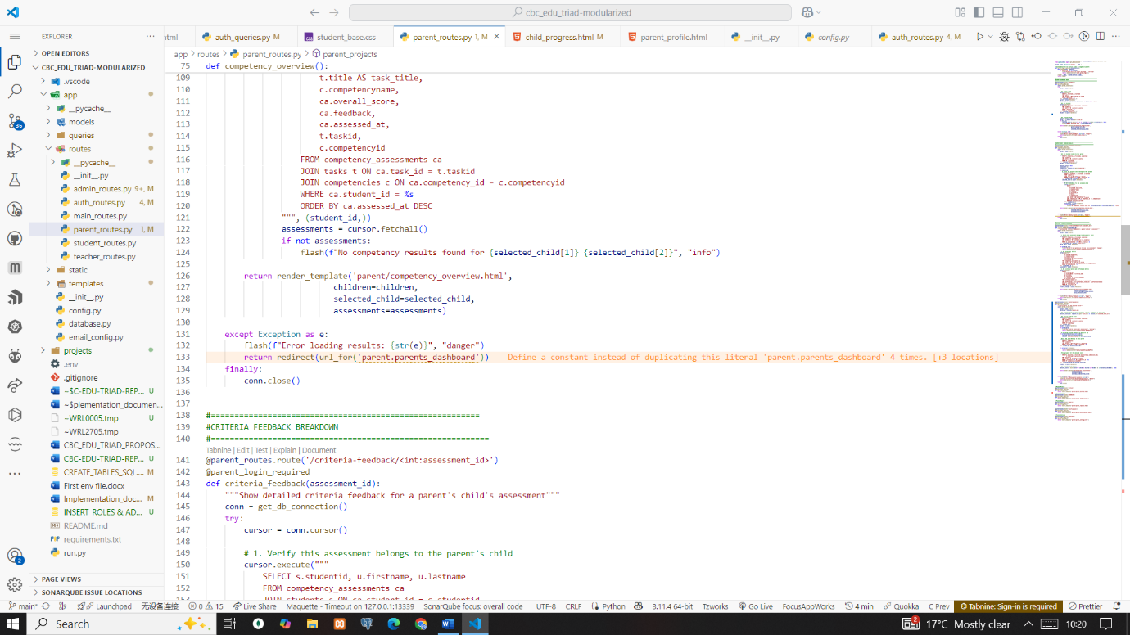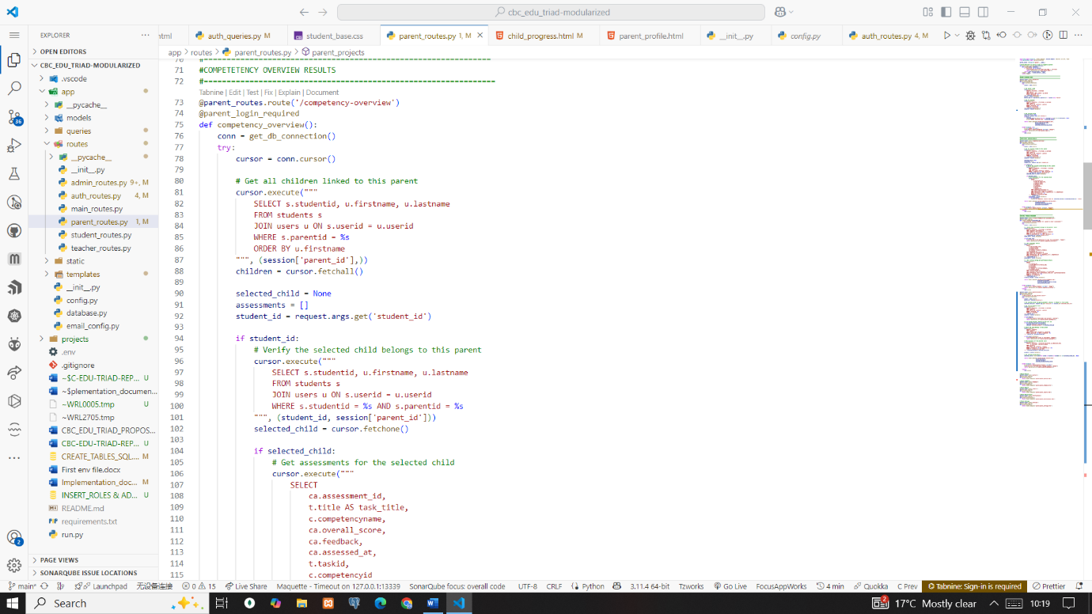The whole long source is available at appendix and reference page

# CHAPTER 7 - SUMMARY, CONCLUSIONS, AND RECOMMENDATIONS

## 7.1 Achievements and Lessons Learnt

This section summarizes the achievements and the technical lesson learned and conclusion.

### 7.1.1 Achievements

This project successfully addressed the core problem of lacking a structured platform for CBC students to showcase innovation and engage with teachers and parents. All specific objectives were achieved as follows

1. A student project showcase module was developed, enabling learners to upload and present their CBC innovation projects online.
2. A competency tracking and monitoring framework based on Competency-Based Education (CBE) and Competency-Based Assessment (CBA) was integrated. This allowed mapping of student projects to specific competencies, performance levels, and rubrics ensuring curriculum alignment and measurable progress.
3. A feedback system was implemented to allow Teachers to assess using CBC-aligned rubrics and feedback students and teachers . Parents to provide encouragement and supportive input without grading responsibility partially met.
4. A role-based, secure web system was implemented, supporting students, teachers, and parents with tailored views and functionalities.
5. Implementing security best practices.
6. Documentation in every sprint

### 7.1.2 Technical Lessons Learnt

1. Modularization the game changer. Helped me enhanced system scalability and maintainability; it also made debugging easier without affecting other parts of the code, improved readability, and simplified implementation.
2. MVC-like separation improved clarity between logic, data, and presentation, allowing for clean, organized, and manageable development.
3. Reusing components like database utilities reduced code duplication and ensured consistency across the system.
4. Using parameterized queries improved security and prevented SQL injection, reducing vulnerabilities.
5. Implementing role-based access control helped enforce user-level security, ensuring data was only accessible to authorized roles.
6. Token-based email and password reset flows strengthened authentication, improving user account management.
7. Timestamping (created at, modified at) helped in auditability and tracking changes, supporting traceability and monitoring.
8. Using CSS variables for theming ensured a consistent UI and made it easy to maintain, switch between light/dark modes, and apply global design updates efficiently.
9. Implementing security best practices ensured safe use:

**Security Lessons Learnt**

Email verification with unique tokens ensured only valid users activated accounts.

Form validation was enforced both client-side (HTML5, JavaScript) and server-side to prevent malicious inputs.

Parameterized queries were used to eliminate SQL injection risks.

Password hashing (SHA256) ensured stored credentials remained secure.

Session management included secure cookies, a 30-minute inactivity timeout, and CSRF protection for forms.

Environment variables (.env) securely stored sensitive DB and email credentials.

Input sanitization and file type validation protected against XSS and malicious uploads.

Role-based access control (RBAC) limited feature access based on user roles.

1. Database Relationship Design Why Foreign Keys Were over inheritance

In the cbc-edu triad system, foreign key relationships were adopted over PostgreSQL table inheritance to ensure secure, scalable, and maintainable associations between users, teachers, students, and parents. Foreign keys promoted referential integrity by enforcing valid relationships every role must be linked to an existing user and support cascading rules such as on delete cascade to automatically maintain data consistency across tables.

Foreign keys also enable efficient and optimized querying. For example, retrieving all teachers can be achieved using straightforward SQL joins, whereas PostgreSQL inheritance would require more complex union all queries across multiple child tables. Additionally, object-relational mapping (ORM) frameworks like flask-SQL alchemy are designed to work seamlessly with foreign key constraints, improving development speed and minimizing bugs (PostgreSQL, n.d.).

Another critical reason for rejecting table inheritance is PostgreSQL’s limitation in enforcing unique constraints and foreign keys across inherited tables. As the PostgreSQL documentation notes, "indexes and foreign key constraints only apply to single tables, not to their inheritance children" (PostgreSQL, n.d.). This design flaw could lead to data duplication and integrity issues in a multi-role system like cbc-edu triad.

## 7.2 Conclusions

The CBC-EDU-TRIAD project successfully addressed the need for a secure, scalable, and competency-aligned assessment platform by developing a modular web system that supports project submission and showcase, task-competency mapping, rubric-based evaluation, and parental monitoring. Built using an Agile approach and MVC-like architecture, the system integrated Role-Based Access Control (RBAC), token-based authentication, and dynamic progress tracking to ensure data integrity and personalized access. Comprehensive testing confirmed 100% success in access control, competency mapping, and feedback delivery. Key lessons emphasized the value of modular design for maintainability and parameterized queries for enhanced security. Future enhancements include; integrating AI-driven grading tools and a mobile application could further improve system usability and reach. Ultimately, CBC-EDU-TRIAD stands as a reliable, user-friendly solution that bridges gaps in CBC assessment while fostering meaningful engagement among students, teachers, and parents.

## 7.3 Recommendations

To build on current success and future-proof of the system, the study recommends:

1. Integrating AI-powered assessment tools to assist teachers in evaluating projects more efficiently and consistently.
2. Developing a mobile app for offline assessment.
3. Incorporating a plagiarism detection tool to maintain originality and academic integrity.

# APPEDICES

**Appendix A  
Source Code Availability**  
The complete, modularized source code is available on GitHub (Wamilimo, 2025).  
GitHub: [https://github.com/wamilimoHillary/cbc_edu_triad‑modularized](https://github.com/wamilimoHillary/cbc_edu_triad%E2%80%91modularized)

# REFERENCES

Asana. (n.d.). *Agile methodology: Definition, examples, and how to get started*. Asana. Retrieved from <https://asana.com/resources/agile-methodology>

Real Python. (n.d.). *Python modules and packages – An introduction*. Retrieved October 10, 2023, from <https://realpython.com/python-modules-packages/>

Burton, L. (2022, December 8). How to use CSS variables: Techniques and best practices for beginners. CSS Snap. <https://www.csssnap.com/use-css-variables-techniques-best>

PostgreSQL. (n.d.). *Inheritance*. PostgreSQL documentation. <https://www.postgresql.org/docs/current/ddl-inherit.html>

Wamilimo, H. (2025). *cbc_edu_triad‑modularized* [Source code]. GitHub. [https://github.com/wamilimoHillary/cbc_edu_triad‑modularized](https://github.com/wamilimoHillary/cbc_edu_triad%E2%80%91modularized) (accessed April 22, 2025)